
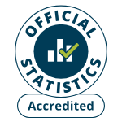
fcommuniCare quality commission

2025 Community mental health survey

Statistical release

NHS Patient Survey Programme

Independent analysis for England published: March 2026
Contents

Summary of findings 4
Positive experiences 5
Key areas for improvement 6
Children and young people’s mental health services 7
Older people’s mental health services 8
1. Introduction 10
2. The Community mental health survey 11
3. Mental health policy 13
3.1 Contextual overview 13
3.2. The role of community services 13
3.3 Demand for services and waiting times 14
3.4 Mental health workforce 15
3.5 Involvement in care 16
3.6 Crisis access and support 16
3.7 Mental health support for young people 18
3.8 Prevention 19
3.9 Inequality 20
3.10 Funding 21
3.11 Digital approach to health care 21
4. Results from the national survey 23
4.1 Support while waiting 24
4.2 Mental health team 26
4.3 Your care 28
4.4 Medication 31
4.5 Psychological therapies 33
4.6 Crisis care access 34
4.7 Crisis care support 35
4.8 Support with other areas of life 36
4.9 Support in accessing care 39
4.10 Respect, dignity and compassion 40
4.11 Overall experience 41
4.12 Feedback 42
5. Results for individual assessment service groups (ASG) 44
5.1 Children and young people’s mental health services (CYPMHS) 44
5.2 Older people’s mental health services 53
6. Subgroup analysis summary: how experience varies for different groups of respondents 58
Questions included in the subgroup analysis 59
Subgroup results 61
Appendix A: Survey methodology 67
Questionnaire design 67
Comparability with previous years 67
Survey methods 67
Sampling 68
Analysis 69
Appendix B: Other sources of information related to survey results 70
Statistics on the use of mental health services 70
NHS mental health dashboard 70
Staffing 71
Waiting times 71
Appendix C: Main users of the survey data 72
Care Quality Commission (CQC) 72
NHS trusts and commissioners 72
Department of Health and Social Care 72
NHS England 72
Patient Experience Library 73
Appendix D: Further information and feedback 74
Further information 74
Further questions and feedback 74
Accredited Official Statistics 74
References 75

Summary of findings
The 2025 Community mental health survey received feedback from 12,319 people aged 16 and over who received treatment for a mental health condition between 1 April and 31 May 2025.

Results from this survey show continued improvement in some areas of care, including support while waiting for care and interactions with staff. However, overall performance remains poor, especially for certain groups.

While results show an increase in the number of respondents knowing who to contact, out of hours, if they are in a mental health crisis (83% in 2025, from 78% in 2024), many respondents are still reporting poor experiences of contacting crisis services and the care they receive. For instance, a quarter of respondents either felt the wait to get through was too long (20%) or they could not get through at all (5%). In addition, for those that did make contact, a third (32%) said they did not get the help they needed. This increases to 51% for those using children and young people’s mental health services.

Survey results were analysed to show how experiences varied for different groups of people. The findings show that younger people, autistic people and disabled people reported worse experiences of care. For example, 46% of disabled people said their mental health got worse while waiting, compared with 26% of respondents without a disability. In contrast, people aged 66 years and over, people who are not disabled and those who have been in contact for less than a year have better experiences. See section 6 for detailed subgroup analysis.

As in previous years, results are also presented by assessment service group (ASG) for children and young people’s mental health services, adult mental health services and older people’s mental health services.

Positive experiences

Support while waiting
Forty-three per cent of respondents said their mental health stayed the same while they were waiting for treatment. However, there was a statistically significant increase in the proportion who reported an improvement (17%, up from 14% in 2023) and a statistically significant decrease in the proportion who said their mental health got worse while waiting (41%, down from 44% in 2023).

More people were offered support for their mental health while waiting (62% compared with 58% in 2023), and the vast majority (92%) felt this support was appropriate ‘completely’ or ‘to some extent’. This is comparable to both 2024 and 2023 (91%).

Mental health team
Experiences improved across key areas:
- Over half of respondents (53%) said they were ‘definitely’ given enough time to discuss their needs and treatment; a statistically significant increase from 51% in 2024 and 50% in 2023. However, 16% were not given enough time, which has remained unchanged since 2023.
- Fifty-five per cent said they were ‘always’ listened to, which is a statistically significant improvement compared with 2024 (52%).
- Nearly half (41%) said they ‘definitely’ received the help they needed, which was a statistically significant improvement from 38% in 2024 and 39% in 2023. However, 22% still reported that they did not get the help they needed.
- Sixty-seven per cent of people said they were ‘always’ treated with care and compassion; a statistically significant increase from 65% in 2023 and 2024. However, 8% responded ‘no’.

Medicine
Over the past 12 months, 78% of respondents said their NHS mental health team had asked how they were getting on with their medicine. Most also said they had clear discussions about their medicines, with 91% saying they had the purpose of their medicine explained to them either ‘definitely’ or to ‘some extent’. In addition, just under 9 in 10 (87%) said they had the benefits of their medicine explained to them ‘definitely’ or to ‘some extent’. There were also increases in the percentage of respondents who had definitely had the side-effects of their medicine explained to them (43% compared to 41% in 2024 and 2023) and what would happen if they stopped taking their medication (43% compared to 41% in 2024 and 39% in 2023).

Support in accessing care
The number of people saying they need support to access care has increased from 28% in 2023 to 35% in 2025). Improvements have been seen in the number of respondents asked by the NHS mental health team if they needed support to access their care and treatment rising to 46% from 44% in 2024 and 41% in 2023. Additionally of those who needed support to access their care and treatment, 66% felt it met their needs either completely or to some extent.

Key areas for improvement

Crisis care
Crisis care should be fast and effective ensuring people get the help they need without delay. However, a quarter of respondents either waited too long for (20%) or could not get through to (5%) to crisis services the last time they contacted them. In addition, around a third (32%) of people said did not get the help they needed when they contacted NHS mental health crisis support. Nearly half (45%) said no support or information was provided by the NHS mental health team to their family or carer while they were in crisis.

Waiting for treatment
Survey findings show that longer waits are associated with poorer experiences, including an increase in respondents reporting that their mental health got worse the longer they waited. People waiting less than 2 weeks between their assessment and first appointment for treatment were the most likely to say their support while waiting was ‘completely’ appropriate (69%), whereas only 23% of people waiting more than 6 months felt the same. The longer people had to wait for treatment, the more likely it was for their mental health to deteriorate. A quarter (25%) of people who waited less than 2 weeks said their mental health got worse while they waited, compared to 67% of those who waited more than 6 months.

Your care
Many people still are not involved in their care planning. Nearly a quarter (23%) were either not involved or were not aware of a plan for their care. While there has been some improvement since 2023, 41% of people are still not having care review meetings (compared with 43% in 2024 and 44% in 2023). Additionally, 22% of respondents said they did not feel supported to make decisions about their care and treatment (a small decrease from 23% in both 2024 and 2023).

Psychological therapies
Thirty-nine per cent of people had not received therapy but would have liked it. This is unchanged from 2024. Just under half (40%) felt they waited too long between their assessment with the NHS mental health team and their first therapy appointment. However, this is a decrease compared with 44% in 2024.

Support with other areas of life
Support with other areas of life can be essential to good mental health, but results show that wider areas of a person’s life are not being supported where people would have liked this support.
- No support with physical health was provided to 38% of respondents though they stated they would have liked it.
- Nearly half (45%) of respondents had not received any help or advice with finding support for joining a group; a small statistically significant increase on 2024 (44%).
- Two-thirds (66%) of respondents were offered no help or advice with finding support for help with money or benefits.
- One in 5 people (20%) would like their family or friends to be more involved.

Children and young people’s mental health services
While there have been some improvements, respondents who have used children and young people’s mental health services (aged 16 and over) continue to have a poor experience. Reasons for this include not being involved in their care planning, long waiting times, support not meeting needs and wider needs not supported.
- Forty-six per cent of respondents waited 3 months or more for their first appointment for treatment. Between their assessment with the NHS mental health team and their first appointment for treatment over half (54%) said they received no support with their mental health.
- Half of respondents (50%) said the waiting time for psychological therapy was too long. Though this is a statistically significant improvement from 2024 (59%).
- In a crisis, 27% of respondents said they had to wait too long and 51% did not get the help they needed.
- Twenty-five per cent of respondents reported they were not involved in a plan for their care or were not aware of one. Furthermore, 45% had not had a care review meeting in the last 12 months.
- Just under a quarter (24%) of respondents had not been told who to contact if they had any questions or concerns about their care or treatment.
- Only a few people who wanted support said they were offered help and advice for getting support with other areas of their life. Eighty per cent received no help with support for finding or keeping work and 84% no help with support for money or benefits. Sixty-two per cent received no help or support for joining a group, an increase from 55% in both 2024 and 2023.

Older people’s mental health services
People who use older people’s mental health services generally reported more positive experiences around waiting times, being treating with dignity and compassion, and the mental health team. However, they reported poorer experiences for questions around involvement in care, therapies and support for wider needs.

- Waiting times improved, with 29% saying they waited less than 2 weeks (compared with 24% in 2024 and 21% in 2023). More people also said they were offered support while waiting (66% compared with 58% in 2024 and 61% in 2023). Additionally, 95% who were offered support said it was completely or to some extent appropriate for their needs.
- Seventy-five per cent of respondents felt the NHS team listened to what they had to say and 85% said they were ’always’ treated with care and compassion (an increase from 82% in 2024).
- Ninety per cent of respondents said they knew who to contact if they had any questions or concerns about their care or treatment.
- One in five (20%) of respondents said they did not have a plan for their care or were not aware of one. However, 76% said they were given a choice in how their care would or treatment would be delivered (an increase from 71% in 2024).
- Thirty-eight per cent have not received any therapies for their mental health needs in the last 12 months but would have liked it.
- Only a few people reported being offered help and advice for getting support with other areas of their life, with 65% not getting any help with support for money or benefits. Thirty-five per cent of respondents did not receive any help or advice with finding support to join a group.

1. Introduction
Good mental health is a fundamental part of overall wellbeing. The World Health Organization defines good mental health as enabling people to cope with everyday stressors, realise their abilities, learn effectively, work productively, and contribute to their communities. Mental health conditions are common with 1 in 5 adults in England living with a mental health problem. Mental health conditions vary considerably from mild and short-term difficulties to severe, complex and long-lasting disorders that may have an impact on people’s daily life.

Community mental health services play a key role in delivering mental health care close to home. As well as providing multidisciplinary support for adults with moderate to severe mental health needs, community mental health care includes specialist services for children and young people up to the age of 25, as well as older people’s mental health services for people aged 65 years and older.

Demand for mental health services continues to rise. Data from NHS England shows there were over 300,000 more people in contact with secondary mental health services in December 2025 than December 2023. Furthermore, figures show that over 850,000 children and young people were accessing mental health services during the 12 months to December 2025.

In addition, Lord Darzi’s 2024 Independent Investigation of the National Health Service in England again underscored the importance of listening to people who use services and their families, and involving them in decisions about their care, while the 2025 Fit for the future: 10-year health plan for England reinforces this by making patient voice and experience central to defining high-quality care.

Against this backdrop of rising demand, system reform, and renewed emphasis on patient experience, the 2025 Community mental health survey provides timely insights into how services are performing and where further improvement is required.

2. The Community mental health survey
The Community mental health survey was launched in 2004 and asks people who use NHS community mental health services in England about their experiences of care.

In 2023, the Community mental health survey underwent a large-scale redevelopment, revising both methodology and questionnaire design. In line with the wider NHS patient survey programme, since 2023 the questionnaire has been available to complete online as well as in paper format.

To support the rebuilding of trend data, minimal changes have been made to the Community mental health survey since its redesign in 2023. For 2025, 3 new questions were added to the paper and online survey (Q13, Q15 and Q19). These covered knowing who to contact with questions or concerns, being involved in a plan for their care and being given a diagnosis. Six new questions were added to the online survey only (X1, X2, X3, X4, X5 and X6). Questions X1 to X5 were reinstated from the 2023 online survey, which explored the experience of people moving from children and young people’s mental health services to adult mental health services.

For more information about changes to the questionnaire and survey development, see the 2025 Community mental health survey development report on the NHS patient surveys website. Information on the methodology, which covers how we developed the survey, analysed data and compared results with previous surveys can be found in Appendix A.

Participants for the 2025 survey:
- Fifty providers of NHS mental health services participated in this year’s survey. This includes combined mental health and social care trusts, foundation trusts and community healthcare social enterprises that provide NHS mental health services.
- Following on from 2023 and 2024, people aged 16 and 17 were still eligible to participate if they were receiving specialist care or treatment for a mental health condition between 1 April and 31 May 2025.
- Fieldwork took place between 18 August and 28 November 2025.
- In total, completed responses were received from 12,319 people who use community mental health services; a response rate of 19%.
- For the 3 assessment service groups, responses were received from 9,105 people who use adult mental health services (response rate 18%), 814 people who use children and young people’s mental health services (response rate 15%) and 2,400 people who use older people's mental health service (response rate 25%).

Basic demographic information was collected from everyone who took part in the survey. This anonymised data is available via the open data published on CQC’s website.

The demographic data indicates a balanced respondent profile in terms of age. There was a lower representation from those 81 and over (7%), but this group saw a small statistical increase compared to the 2024 and 2023 survey (both 6%). Females represented 62% of all respondents. When considering ethnic group, most respondents were white (87%), which shows no statistically significant change compared to 2024 and 2023.

This year the survey asked if respondents had a community treatment order (CTO). A CTO can be used to require a person being discharged from detention in hospital to follow certain conditions in the community. This could include, for example, living at a particular address, attending appointments for treatment, and staying in touch with a care team. Seven per cent of respondents had a treatment order in place or had one in place in the last 12 months, but it has now ended.

3. Mental health policy
This section looks at policy and contextual issues relevant to NHS community mental health services in England. The 2025 Community mental health survey captures the experiences of people aged 16 and over, so the scope of the policy review will largely be bound by this age demographic.

3.1 Contextual overview
Community mental health services play a key role in delivering mental health care close to home. As well as providing multidisciplinary support for adults with moderate to severe mental health needs, community mental health care includes specialist services for children and young people up to the age of 25 as well as older people’s mental health services for people aged 65 years and older. They are commissioned locally by Integrated Care Systems (ICSs), whose aim is to improve health and care services through a focus on prevention, better outcomes and reducing health inequalities. Service configuration can vary between ICSs.

Transformation of mental health services has remained central to national policy. In 2016, the Mental Health Taskforce published the Five year forward view for mental health. This was followed by the NHS long term plan and the NHS mental health implementation plan 2019/20 to 2023/24, both with a focus on integrated community-based care, understanding the root cause of mental ill-health and proactively tackling health inequalities. Since then, the policy landscape has continued to evolve with the Mental Health Act 1983 (amended 2025) and the Fit for the future: 10-year health plan for England published in 2025.

3.2. The role of community services
Since the introduction of generic community mental health teams nearly 40 years ago, community mental health services have provided essential but often under-recognised support, delivering care closer to people’s homes and communities.

In recent years, there has been increasing recognition of the important role of community-based services. For example, in 2019 the Community Mental Health Framework for Adults and Older Adults emphasised the importance of timely access to NICE-approved psychological therapies for people with long-term severe mental illnesses in community settings. Similarly, the NHS Long Term Plan, also published in 2019, aimed to introduce new models of community mental healthcare to support people to live well in their communities. This was replaced in 2025 with 10-year health plan for England which set out 3 key shifts: hospital to community care, analogue to digital systems, and moving from reactive to preventive approaches.

In July 2025, as part of the 10 year health plan for England, NHS England announced the first 6 providers chosen to pilot a 24/7 neighbourhood mental health centre. These centres bring together a range of services under one roof, including crisis services, community mental health services and short-stay beds. People with serious mental illness such as schizophrenia or bipolar will also be able to walk in without an appointment if they need mental health support, as well as advice on employment, housing, or volunteering.

The Mental Health Act 2025 (revised Mental Health Act 1983), which received royal assent in December 2025, introduced changes to existing community powers. Changes include establishing stricter criteria for the use of community treatment orders (CTOs) and increased input by the community clinician. The government also plans to review the overall implementation and value of CTOs. As noted by NHS Confederation, timings for this review and expected changes are to be confirmed.

3.3 Demand for services and waiting times
Demand for secondary mental health services remains high. Data from NHS England shows there were over 300,000 more people in contact with secondary mental health services in December 2025 than in December 2023. Furthermore, figures show that over 850,000 children and young people were accessing mental health services during the 12 months to December 2025.

As reported in the government’s Mental health and wellbeing plan discussion paper from 2023, delays in accessing help can lead to mental health problems escalating while early intervention has been found to produce better long-term outcomes.

Evidence shows that increasing demand for services has led to delays in treatment. The 2024 Community mental health survey reported that 4 in 10 people felt they had waited too long for care. One-third waited 3 months or more for their first treatment, and those experiencing the longest waits (6 months or more) were the least likely to receive support while they waited. Lord Darzi’s Independent investigation of the NHS in England reported how these long waits have become normalised. It also highlighted that the time people must wait and the quality of the treatment they receive is at the heart of the social contract between the NHS and people who use services.

The challenge, in part, continues to stem from the lack of waiting time targets for many mental health services. The Five year forward view for mental health, NHS mental health implementation plan 2019/20 to 2023/24 and the 2021 mental health clinically-led review of standards set out a plan to deliver waiting time standards. NHS England currently publishes access and waiting time standards for 3 mental health pathways:
- Early intervention in psychosis (EIP) – 60% of people with a first episode of psychosis to start treatment within 2 weeks of referral.
- Children and young people’s eating disorder services – 95% should receive treatment within 1 week for urgent cases and 4 weeks for every other case.
- Consultant-led mental health services – treatment within 18 weeks.

Data from NHS England shows that the target of 60% of people with a first episode of psychosis to start treatment within 2 weeks of referral are being met. It is not currently possible to identify from this data if the targets around children and young people’s eating disorder services are being met.

The 2022 mental health clinically-led review of standards proposed that for non-urgent, community mental health care, adults and older adults should start to receive help within 4 weeks from referral. Furthermore, children, young people and their families and carers, and adults and older adults presenting to community-based mental health services should also start to receive help within 4 weeks of referral. The NHS 4-week standard for community-based mental health remains yet to be mandated. Currently, there are no waiting times standards covering all mental health service areas.

In his 2024 report, Lord Darzi concluded that since 2015 the NHS has not been able to meet the most important promises made to people using services, such as community mental health access standards. The 10-year health plan for England indicates that the use of private providers will continue in an attempt to improve access and reduce waiting times thereby returning the NHS to its constitutional standards.

3.4 Mental health workforce
Meeting NHS workforce needs is a multifaceted challenge balancing increasing numbers waiting for care with overall staffing numbers, recruitment levels across different staff roles and retention. Since 2016 several national plans, including Stepping forward to 2020/21: the mental health workforce plan for England and the NHS mental health implementation plan 2019/20 to 2023/24, have focused on increasing staffing numbers across the mental health workforce.

In 2023, the NHS long term workforce plan committed to growing the number and proportion of NHS staff working in mental health, primary care and community care by 73% by 2036/37. This was followed in October 2024 with a commitment from NHS England to recruiting an additional 8,500 mental health workers across child and adult services to reduce delays and provide faster treatment. These would be across the current workforce mix and split within NHS trusts and other core organisations in England. This commitment was reiterated as part of the 10-year health plan for England. As of June 2025 6,700 more mental health workers have been recruited.

NHS vacancy statistics from September 2025 show a total workforce vacancy rate of 6.7% with a mental health team vacancy rate of 9.1%. This equates to 24,297 full-time mental health posts with vacancies. There are signs that vacancies are being filled as mental health team vacancies in England fell from 10% to 8.9% between September 2024 and September 2025.

However, increasing demand continues to put pressure on the mental health workforce. Data from the Royal College of Nursing shows that demand for secondary mental health service in England more than doubled between 2014 and 2024, rising from 1.8 to 3.8 million contacts and referrals, while the number of mental health nurses per 10,000 patients nearly halved. The government has acknowledged that increasing in demand for mental health services, and the resulting pressure on the workforce, has led to negative impacts on staff workloads, burnout rates and morale.

Workforce training is a key element to reducing vacancy rates. The 2023 NHS long term workforce plan aims to increase training places for mental health nursing by 38% by 2028/29 increasing to 93% (more than 11,000 places) by 2031/32. The introduction of 8,500 additional roles may require corresponding growth in education and training provision.

3.5 Involvement in care
It is essential to recognise and address individuals' experiences of care, their participation in personal healthcare decisions, and the perspectives of carers and family members. However, Lord Darzi’s Independent Investigation of the NHS in England identified that the patient voice is not loud enough. The report emphasised how people are less empowered to make choices about their care.

Not listening to people, including families, has been a key theme raised in patient safety reviews, and the 2024 Community Mental Health Survey found that over a third (38%) of respondents said they did not have a care plan. The 2024 Guidance to integrated care boards on intensive and assertive community mental health care recommended that engagement with families, carers and close friends should be seen as standard practice for all people with a severe mental illness, and not limited to times of relapse.

The NHS 10-year health plan for England places renewed emphasis on patient choice and experience, responding to concerns that previous efforts to improve quality focused primarily on safety, but not equally on clinical effectiveness and patient experience. Patient experience data is routinely collected, including by the Care Quality Commission’s NHS patient survey programme. However, Dr Penny Dash's 2025 Review of patient safety across the health and care landscape in England highlighted that despite multiple organisations collecting patients ‘voice’, most NHS boards lack an executive director for customer or user experience which risks a lack of action and change. The 10-year health plan outlines the new role of National Director of Patient Experience responsible for overseeing the collection of more informed feedback from both patients and carers. This includes patient reported outcome measures (PROMs – currently used in mental health) and patient reported experience measures (PREMs) to be used universally and made available via the NHS app by 2029.

NICE guidance suggests that people who use services should be involved in decisions about their health and care and should have a care plan. A care plan is a record of the help and support people need and should give them choice and control over their care. The NHS 10-year health plan for England aims for people to be active participants in their own care by ensuring 95% of people with complex needs have an agreed care plan in place by 2027. It stresses that family, friends and unpaid carers should be involved in developing care plans. Care plans should be reviewed every 12 months to monitor progress and changes, consider how the care is meeting needs and determine what might be needed in the future. However, a review should occur more frequently if circumstances change or mental health worsens.

3.6 Crisis access and support
During periods of mental ill-health, an individual may experience a crisis. Signs of a mental health crisis can vary but may include severe anxiety, self-harm, or suicidal thoughts. Alongside hospital-based treatments, community-based mental health services can play a vital role in providing timely support.

The Five year forward view implementation plan, NHS long term plan and 10-year health plan for England have all committed to improving access to mental health crisis care and decreasing waiting times for crisis services. In 2021, as part of the clinically-led review of standards, NHS England consulted on new proposals for mental health waiting times metrics across both urgent, emergency and community NHS-funded mental health care.

NHS England’s access and waiting time standards state that people in crisis referred from an emergency department should be seen within 1 hour of referral. For a ‘very urgent’ referral to a community-based mental health crisis service, a patient should be seen face-to-face within 4 hours from referral, for all age groups. For an ‘urgent’ referral to a community-based mental health crisis service, a patient should be seen face-to-face within 24 hours from referral, across all ages.

Providers submit data on these standards to NHS England’s Mental health services data set (MHSDS). Figures for December 2025 show that 39,252 people had an urgent referral to a crisis team, and 7,409 referred to crisis teams had their first face to face contact within 24 hours.

In August 2024, NHS England announced that people of all ages who are in crisis, or concerned family and loved ones, would be able to use NHS 111 to speak to a trained mental health professional and access a 24/7 full package of mental health crisis support.

Many people experiencing a mental health crisis go to A&E due to the urgency and severity of their situations or because of long wait times for other mental health services. However, the 10-year health plan for England highlights that emergency departments are not always well suited to addressing mental health needs, and mental health services have historically been insufficiently integrated into urgent care pathways.

In July 2025, the government announced as part of the 10-year health plan for England that it would be investing up to £120 million to develop more dedicated mental health emergency departments (MHEDs), to ensure patients get fast, same day access to specialist support in an appropriate setting. These units will provide walk-in access, receive patients conveyed by ambulance, or referred by the police or 111 and carry out rapid assessment typically within 4 hours, alongside short-term support and safe discharge or onward referral.

The Royal College of Psychiatrists have raised concerns that developing separate units will reinforce the stigma surrounding mental illness and that MHEDs will lead to challenges dealing with co-occurring physical and mental health conditions. However, the 10-year health plan for England stresses that MHEDs will work closely with A&E teams to make sure any physical health needs are met.

3.7 Mental health support for young people
Providing children and young people with fast access to early, high-quality support can be essential for long term, good mental health as mental health difficulties experienced as an adult have often developed in childhood or young adulthood. Successive governments have pledged to improve mental health support for children and young people. Following the green paper Transforming children and young people’s mental health provision and the NHS long term Plan, the 2025 10-year health plan for England aims to provide a solid foundation for a thriving life, embedding support for children and young people in schools and colleges.

Children and young people's mental health services are typically delivered or commissioned by the NHS, but may include NHS-funded support from local mental health organisations such as charities and social enterprises, as well as mental health support teams (MHSTs) in schools and colleges. While these services are generally available to children and young people under 18-years of age, in some cases they may support people up to the age of 25.

The 2019 NHS long term plan committed to increasing children and young people’s access to NHS funded mental health services and school or college-based MHSTs. In January 2024, the government committed to reaching 50% of pupils and learners by the end of March 2025. As of spring 2025, 600 MHSTs were operational reaching 52% of pupils and learners. In the 10-year health plan for England and 2025 Spending review the government committed to continuing the roll out of MHSTs to reach full national coverage by 2029 to 2030.

Further specific support has been outlined in the Suicide prevention strategy for England: 2023 to 2028, which focuses on prevention and early intervention in preventing suicide. All state schools and colleges were offered funding to train a senior mental health lead by 2025 and to consider the inclusion of suicide and self-harm prevention as an explicit part of the curriculum. Training grants for senior mental health leads were offered to all state schools and colleges in England between October 2021 and December 2024. In July 2025 the Department for Education published new guidance that mandated the addition of suicide prevention to secondary school curriculums.

Outcome metrics for children and young people’s mental health were first set out in the Five year forward view for mental Health and later implemented by NHS England through paired scores published in NHS England’s MHSDS. Paired scores compare 2 observations to assess change between the first and last measurement. In May 2025, paired scores were available for 7,432 discharged children and young people, showing measurable improvement for 3,620, deterioration for 713 and no change for 3,099. Although the volume of paired scores has increased since last year, the proportions across outcome categories remain largely unchanged.

Between the ages of 16 and 25 years, young adults will transition from children and young people’s mental health services to adult mental health services. Guidance from the National Institute for Health and Care Excellence (NICE) recommends that this should start in school year 9 (aged 13 to 14 years), or immediately after. Some adults have reported feeling inadequately supported during this transition, which can lead to disrupted care or disengagement from the service. A primary aim of the 2019 Community mental health framework was to strengthen continuity of care and ensure people get the support they need.

There are plans to provide more ways for young people to access support. The 10-year health plan for England and the Department for Culture, Media and Sport’s new National Youth Strategy set out support, including support for mental health, wellbeing and the ability to develop positive social connections. This in part will take the form of Young Futures hubs where young people can access mental health, career and pastoral support within their communities, to ensure there is no ‘wrong front door’ for people seeking help.

3.8 Prevention
People with severe mental illness (SMI) are at higher risk of poor physical health and die on average 15 to 20 years earlier than the general population. Policies to address this gap have been in place for over a decade, with parity of esteem between mental and physical health established in law in the Health and Social Care Act 2012. This was followed by further commitments in the 2016 Five year forward view for mental health and the NHS long term plan.

In 2018, the government green paper Prevention is better than cure highlighted the importance of adopting a prevention-first approach to mental health care, and the long-term financial benefits of investing in prevention. More recently the 10-year health plan for England emphasised how strong preventative support can help people thrive and significantly reduce lifetime NHS expenditure. The plan highlights the role that mental health emergency departments play in working closely with physical health urgent and emergency care teams to make sure any physical health needs are met. It also highlights the benefits of physical activity for both physical and mental health.

Wider socioeconomic factors also play a significant role in mental ill-health and its prevention. This is recognised in the 2019 Community mental health framework for adults and older adults, which specifies a whole-person, whole-population approach to care that bring together psychological therapies, medicines management, physical health checks, employment support, and support for self-harm and co-existing substance use. In addition, the government’s Plan for change, published in 2024, commits to addressing wider issues, such as homelessness and unemployment, by working beyond the health system and supporting people into employment. Integrated care systems prevention planning similarly emphasises upstream investment, including housing support, debt advice, employment support and social prescribing.

Effective prevention also relies on active engagement from people who use services. Lack of engagement may arise when services do not meet people’s needs, reflect previous negative experiences of care, lack cultural relevance or understanding, or when a person does not recognise that they are unwell or require treatment. In July 2024, NHS England issued targeted guidance to ensure integrated care boards have clear policies for assertive community treatment and follow-up for people with serious mental illness who may struggle to engage. For this group of people, it is critical that services can respond flexibly by adapting how they engage with the person, maintaining continuity of care, and providing a range of treatment pathways suited to differing levels of need.

3.9 Inequality
Lord Darzi’s Independent Investigation of the NHS in England found access to consistent, high-quality health care is not equal for all. NHS England recognises that people living in the most deprived areas of England, people from ethnic minority groups and those from an inclusion health group are most at risk of experiencing inequalities. Reasons for inequality in health care are complex but include social factors, and systemic and structural barriers. Evidence from the King’s Fund highlights how these health inequalities are unfair and avoidable.

There have been efforts in recent years to reduce inequality. The 2019 Community mental health framework sought to address systematic barriers to accessing mental health care. It aimed to move away from fragmented, siloed services that were hard to reach, towards joined-up whole population care approaches with an emphasis on equality of access and culturally appropriate care, particularly for people from communities traditionally underserved.

NHS England’s Advancing mental health equalities strategy, published in October 2020, also outlined plans for addressing inequalities in access, experience and outcomes in mental health care. The strategy recognised how ‘intersectionality’, that is factors such as gender, ethnicity, age and socioeconomic status, may combine uniquely for each person to shape their experience of inequality.

This was followed in 2021 by Core20PLUS5. This strategy focuses on the 20% of the population living in the most deprived areas, as identified by the Index of multiple deprivation (IMD). It prioritises 5 clinical areas, including ensuring that people with severe mental illness receive annual physical health checks. In 2022, the model was adapted for children and young people, with one of the priority areas aimed at improving access to mental health services for 0 to 17-year-olds for certain groups based on ethnicity, age, gender and deprivation.

People from ethnic minority groups are particularly at risks of experiencing poorer quality health care compared with non-minority groups. In October 2023, NHS England launched the Patient and carer race equality framework (PCREF). This framework supports trusts and providers to becoming actively anti-racist organisations by ensuring that they are responsible for co-producing and implementing concrete actions to reduce racial inequalities within their services. PCREF became mandatory for every mental health trust in England from April 2025.

The 10-year health plan for England continues with the ambition for uniting community care, primary care, mental health care, hospitals, social care providers, local government and the voluntary sector. It aims to increase healthy life expectancy while also halving the gap between the richest and poorest regions.

High-quality data is essential for understanding inequalities in mental health care. The 2020 Advancing mental health equalities strategy emphasised the need to routinely use outcome measures and national reporting, linked with demographic information, including protected characteristics, to inform decision-making and develop equality metrics. The Mental Health Services Data Set (MHSDS), established in 2025, provides national data on those services with specific standards or delivery commitments.

3.10 Funding
The 10-year health plan for England acknowledges that increased funding has not consistently resulted in improved patient care. The plan states that despite a decade of rising expenditures, outcomes have declined, productivity has decreased, waiting lists have grown, and access to services has diminished.

Until 2018, mental health spending grew at around 1% a year in real terms. In June 2018, the NHS long term plan outlined plans to increase funding by an average of 3.4% a year over the next 5-years. However, Lord Darzi’s Independent investigation of the NHS in England found that between 2019 and 2024 there was overall an increase to just under 3% a year in real terms. Similarly, the 2024 to 2026 Health and Social Care Committee report on community mental health services reported that, while the 2025/26 mental health expenditure increased from the previous year (£15.6 billion up from £14.9 billion in 2024/25), the share of NHS spending has fallen slightly from 8.78% to 8.71%.

In January 2025, the government published Road to recovery: the government's 2025 mandate to NHS England. As well as discussing financial constraints and the importance of investment, planning and financial management, it noted that how funding is allocated for mental health services is a key issue. It highlighted how community services are currently receiving too small a share of the budget.

At the same time, recent policy changes such as the 10-year plan‘s shift from hospital to community and the Mental Health Act 2025’s focus on reducing detention, place greater demand on community care. This suggests that the proportion of funding allocated to community-based care may need to increase to deliver the intended reforms.

The 2024 House of Commons research briefing on mental health policy and services in England outlined that most local mental health funding is not ring-fenced, therefore individual integrated care boards (ICBs) must determine their own mental health budget from their overall funding allocation. From April 2021, all ICBs received expansion and transformation funding totalling nearly £1 billion over the NHS long term plan period. In 2024–25, NHS England invested a further £414 million to continue developing adult community mental health services. Local areas are expected to meet the Mental health investment standard (MHIS) to increase mental health spending faster than their general funding rise. This was met by all 42 ICBs in 2024/25, as it was in 2023/24.

3.11 Digital approach to health care
As part of its 10-year health plan for England the government outlined its aim to shift the NHS from analogue to digital. Digital tools have the potential to provide better care for people, such as through 24/7 access to virtual therapists, as well as improve joined up working between services. This includes, for example, the introduction of virtual multidisciplinary teams (MDTs). However, research from the National Institute for Health and Care Research has highlighted potential challenges and concerns with the increasing use of digital tools. For example, it found that people with a serious mental illness are twice as likely to lack foundation digital skills. Poor concentration, memory difficulties, psychosis, and trust and privacy concerns can also limit the consistent use of digital tools.

4. Results from the national survey
This section presents the national findings from the 2025 Community mental health survey, which asks people about their experiences of using NHS community mental health services in England. Historical comparisons are available with the 2023 and 2024 data where this is possible.

The findings are grouped into the following themes:

- Support while waiting
- Mental health team
- Your care
- Medication
- Psychological therapies
- Crisis care access
- Crisis care support
- Support with other areas of life
- Support in accessing care
- Respect, dignity and compassion
- Overall experience
- Feedback

This section also includes the results of a ‘subgroup analysis’, which considers the experiences of different groups of people, according to demographic, health, and care characteristics. Further details are available in section 6. Subgroup analysis summary.

Please note: Responses to questions such as “don't know/can’t remember” are not shown and are excluded from percentage calculations. Other non-specific response options are also excluded, such as where the respondent does not require the service – for example, “I do not need support for this”. Additionally, the respondent numbers shown below the charts are weighted values.

4.1 Support while waiting
The NICE quality statement on access to services emphasises the importance of ensuring people can receive high-quality mental health support when they need it. However, demand for secondary mental health services remains high, leading to delays in treatment within an already overstretched system. Lord Darzi’s investigation noted that long waiting times have become normalised, and the Mental health and wellbeing plan discussion paper highlights that delayed help can cause mental health problems to worsen. In contrast, early intervention is associated with better long-term outcomes. Support provided to people while they are waiting for treatment may include:
- immediate advice or brief interventions
- help to access a more appropriate service
- the beginning of longer-term care
- the development of a care plan or specialist assessment.

To understand the impact of waiting times and support offered, the 2025 survey asked respondents about their experience of mental health care between their assessment and their first appointment. Survey respondents were first asked how long they waited between their assessment with the NHS mental health team and their first appointment for treatment. One in four (25%) respondents waited less than 2 weeks; 14% waited more than 6 months, which was a statistically significant reduction from 2023 (15%).

Respondents were then asked if they experienced any changes in their mental health while waiting. This year saw a statistically significant increase in respondents who stated their mental health improved while waiting (17% compared with 14% in 2023) and a statistically significant decrease on their mental health getting worse (41% compared with 44% in 2023) (Figure 1). However, those feeling they waited too long for treatment (39%) has remained stable since 2023.

Figure 1: While waiting, between your assessment with the NHS mental health team and your first appointment for treatment, did you experience any changes in your mental health? (Q5)
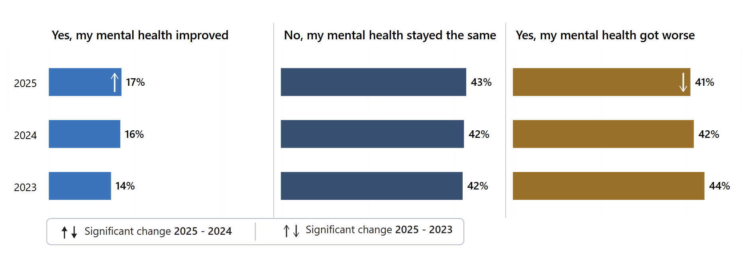
Answered by those who have been in contact with NHS mental health services for the past 2 years. Respondents who stated that they didn't know or couldn't remember have been excluded. Total number of respondents: (2023) 5,211, (2024) 5,062, (2025) 4,416.

To further explore the impact of waiting times, question 5 (While waiting, between your assessment with the NHS mental health team and your first appointment for treatment, did you experience any changes in your mental health?) was considered against question 3 (How long did you wait between your assessment with the NHS mental health team and your first appointment for treatment?). Results show that the highest percentage of respondents who felt their mental health improved waited less than 2 weeks (28%), whereas the highest percentage of people who felt their mental health got worse waited more than 6 months (67%).

To understand any potential inequality in care, question 5 was considered for respondents with and without a disability. Forty-six per cent of disabled respondents reported their mental health got worse while waiting compared with 26% without a disability.

Appropriate support
Respondents were asked if they were offered support with their mental health between their assessment with the NHS mental health team and their first appointment for treatment. Sixty-two per cent said they were offered support, representing a statistically significant increase compared with 2023 (58%). Of those offered support, 92% felt it was ‘completely’ or ‘to some extent’ appropriate for their mental health needs, consistent with both 2023 and 2024 findings (91%).

Respondents who had waited for less than 2 weeks were most likely to report their support as being ‘completely’ appropriate (69%). Whereas, for those that had been waiting more than 6 months for treatment, only 23% felt their support was ‘completely’ appropriate (Figure 2).

Figure 2: Cross-tabulation of ‘How long did you wait between your assessment with the NHS mental health team and your first appointment for treatment?’ (Q3) by ‘Was the support offered appropriate for your mental health needs?’ (Q7).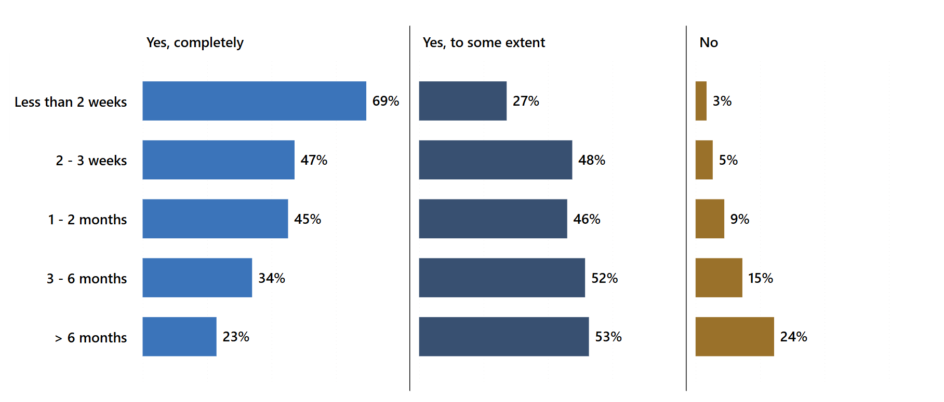Answered by those who have been in contact with NHS mental health services for the past 2 years. Respondents who stated that they didn't know or couldn't remember have been excluded from q7 and q3. Respondents who stated that they did not need any support have been excluded from q7. Total number of cross-tab respondents: 1,990.

4.2 Mental health team
NHS mental health teams provide support to individuals in the community with complex or severe mental health conditions. Positive, respectful interactions between people delivering and people using services are essential to achieving good care outcomes. Establishing a therapeutic relationship enables individuals to discuss their mental health and wider life circumstances. This requires people to feel listened to and for appointments to be of sufficient length, even amid increasing service pressures.

Survey respondents were asked if they were given enough time to discuss their needs and treatment during their appointments. Over half responded ‘yes, definitely’ (53%), which was a statistically significant increase on 2024 and 2023 (51% and 50% respectively). Approximately 1 in 6 respondents (16%) were not given enough time, which has remained consistent since 2023. Furthermore, 55% of respondents reported that they were 'always' listened to, representing a statistically significant increase compared with 2024 (52%). Subgroup analysis identified groups reporting poorer experiences for both being given enough time and being listened to, including people aged 16-50 (16-65 for being given enough time), those receiving telephone-based care, disabled and autistic respondents, and people who have received inpatient care within the last 12 months. Among other groups, men and those of Christian and Muslim faith reported better than average experiences for being listened to.

Respondents were also asked if their NHS mental health team considered how areas of their life impacted on their mental health. Nearly half (49%) said they were ‘definitely’ asked, a statistically significant increase from 2024 (46%) and 2023 (46%). Nearly 1 in 5 people (18%) said they were not asked. Subgroup analysis showed respondents reporting poorer than average experiences included disabled people, autistic people and those aged 16-35.

When respondents were asked if they got the help they needed, nearly a half (41%) answered ‘yes, definitely’ which was a statistically significant increase on 2024 and 2023 (Figure 3). Subgroup analysis indicated again that groups who reported worse than average experience were younger (aged 16-50), disabled people, autistic people and those who received their support over the telephone. Other groups reporting poorer than average experiences were those who received their care via multiple modes of contact and people with a neurological condition.

Figure 3: Did you get the help you needed? (Q10)
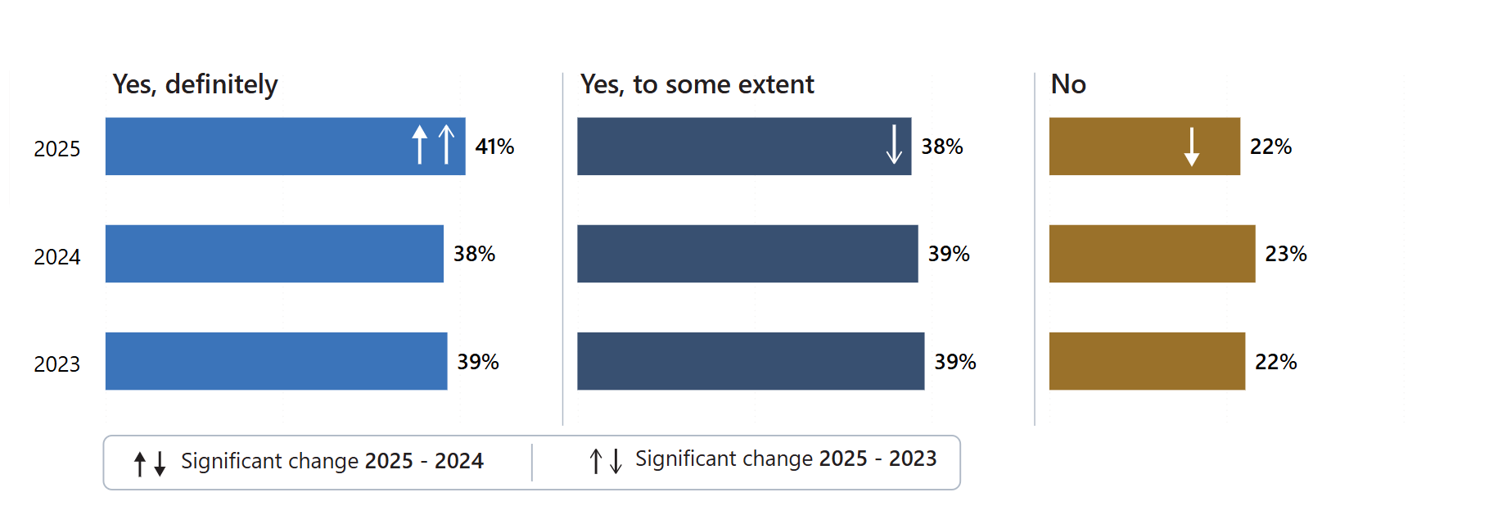Answered by all. Respondents who stated that they didn't know or couldn't remember have been excluded. Total number of respondents: (2023) 14,200, (2024) 13,909, (2025) 11,713.

The survey asked respondents if their mental health team told them who to contact if they had any questions or concerns about their care or treatment (this was a new question for 2025). Seventy-nine per cent of people answered ‘yes’; however, over 1 in 5 (21%) had not been told. Subgroup analysis highlighted poorer than average experiences for groups already mentioned above, including people aged 16-50 years old, disabled people, autistic people, and those who received their support over the telephone. Better than average experiences were seen in respondents who had been in contact with services for 2 years or under.

4.3 Your care
Lord Darzi’s Independent Investigation of the National Health Service in England identified that the patient voice is not loud enough. It is essential to recognise and address individuals' experiences of care, their participation in personal healthcare decisions, and the perspectives of carers and family members. In line with NICE quality statement 2, the aim should be to adopt a model that promotes active participation in treatment decisions and supports self-management. People who use services should participate in personal healthcare decisions and should have a care plan. The NHS Fit for the future: 10-year health plan for England aims for people to be active participants in their own care by ensuring 95% of people with complex needs have an agreed care plan by 2027.

The survey asked respondents if their NHS mental health team involved them in a plan for their care. Just under half (44%) said they were ‘completely’ involved, whereas 23% were either not involved or were not aware of a plan for their care (Figure 4).

Figure 4: Did your NHS mental health team involve you in a plan for your care? (Q15)
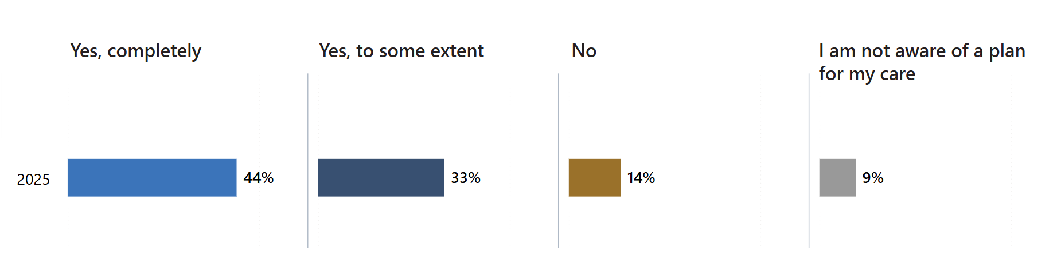
Answered by all. Respondents who stated that they did not want to be involved have been excluded. Total number of respondents: (2025) 11,884.

Subgroups who reported better than average experiences of being involved in a plan for their care included those who accessed services face-to-face or via video conferencing and had been with mental health services less than two years. Worse than average experiences were once again reported by those whose mode of contact was over the telephone, disabled people and autistic people.

Care plans should be reviewed regularly. A review every 12 months should monitor progress and changes, consider how the care is meeting needs and determine what might be needed in the future. However, a review should occur more frequently if people’s circumstances change or their mental health worsens. This can include family, friends and unpaid carers.

Respondents were asked if, in the last 12 months, they have had a care review meeting with their NHS mental health team to discuss how their care is working. Fifty-nine per cent responded that they had a care review meeting, which is a small but statistically significant increase from both 2024 (57%) and 2023 (56%). However, this leaves 41% of people not having care review meetings.

People aged 16 to 50 years old also reported a poorer experience of having had a care review meeting, as well as people who were contacted only by telephone, disabled people, and autistic people.

In addition to being involved in developing their care plan, people using services should be supported to make decisions about how their care is delivered. The 2025 survey asked respondents whether they were given a choice in how their care and treatment would be delivered. Just under a third (32%) reported having no choice. However, this represents a statistically significant improvement from 2024, when 36% said they had no choice in how their care and treatment would be delivered.

Subgroup analysis identified that some groups were more likely to report a poorer experience of having a choice about how their care would be delivered. These included those aged 16 to 50 and who received care via the telephone. Whereas, better than average experiences were experienced by those:
- aged 66-80
- of Christian or Muslim faiths
- in contact with services for 2 years or less
- whose mode of contact was face-to-face or via video conferencing.
The survey asked respondents if their NHS mental health team supported them to make decisions about their care and treatment. Just under a half (46%) felt they were ‘definitely’ supported, which is a statistically significant increase on 2024 (41%) and 2023 (42%). However, 22% felt unsupported in making these decisions (Figure 5).

Figure 5: Has your NHS mental health team supported you to make decisions about your care and treatment? Support includes sharing information on risks and benefits of your care and treatment. (Q18)
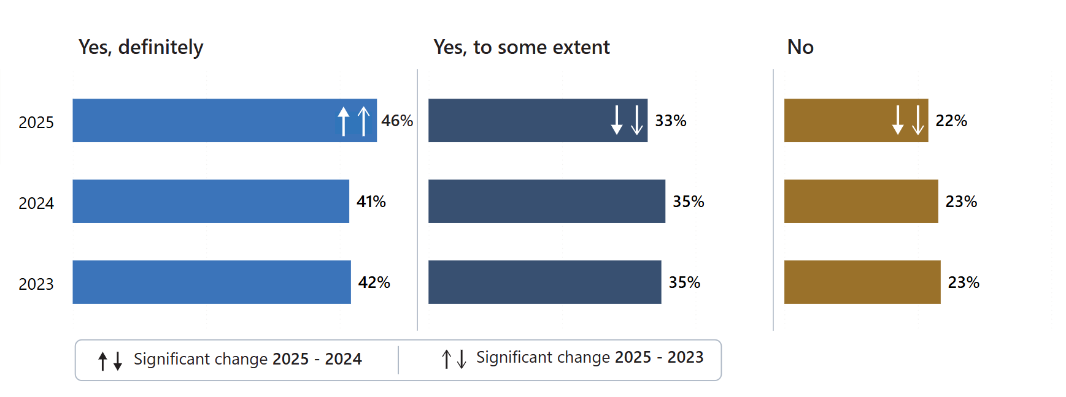
Answered by all. Respondents who stated that they didn't know or couldn't remember have been excluded. Total number of respondents: (2023) 13,629, (2024) 13,262, (2025) 11,276.

Subgroups who reported better experiences of being supported to make decisions about their care and treatment were those aged 66 to 80, those who received care face-to-face or via video conferencing, and those who were in contact with services for 2 years or less. Poorer experiences were reported by groups previously mentioned for other areas of care (those aged 16 to 50, those receiving care via the telephone, disabled people, and autistic people).

This year the survey asked if respondents had been given a diagnosis for their mental health. Overall, 1 in 5 (20%) had not been given a diagnosis, whereas 68% had received a diagnosis and 11% had received one but it had changed (Figure 6). Subgroup analysis showed that, among other groups, those aged 16-35 were less likely to have received a diagnosis, while those with dementia were more likely than average to have a diagnosis.

Figure 6: Have you been given a diagnosis for your mental health? (Q19)
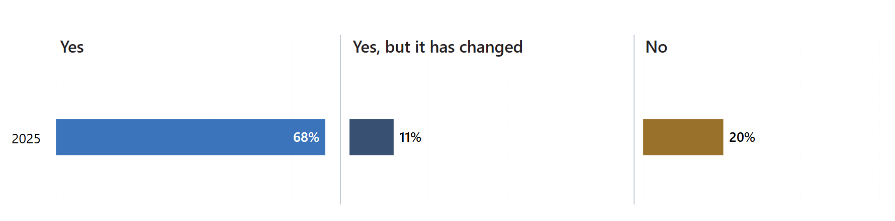
Answered by all. Respondents who stated that they didn't know or couldn't remember or preferred not to say have been excluded from q19. Total number of respondents: (2025) 10,970.

4.4 Medication
Non-adherence to treatment can occur frequently for people with mental ill health. The reasons for this are multifaceted and may include an individual’s perception of illness and medication, adverse side effects, and some demographic characteristics such as homelessness. Full therapeutic benefit is not achieved if people do not take their medication as prescribed.

NICE guidance recommends involving people in decisions about their prescribed medicines. There must be the opportunity to take part in decisions about their prescribed medicines, including openly discussing the advantages and disadvantages of any proposed treatment. This includes recognising the patient’s right to decline the medication.

Among those receiving medication for their mental health needs (85% of all respondents), 78% reported that their NHS mental health team had asked how they were getting on with their medication over the past 12 months. Respondents were then asked a series of questions, focusing on specific discussions about their medicines, including the purpose, benefits, side-effects and what would happen if they stopped taking their medication.

When asked if the purpose of their medication had been explained, 91% of respondents answered ‘yes, definitely’ or to ‘some extent’. Over half (56%) ‘definitely’ had the benefits of their medication explained, an increase compared with 54% in 2024. However, over 1 in 4 (28%) had not had the side-effects of their medication explained, though this is a statistically significant improvement on 30% in 2023. Forty-three per cent of respondents were ‘definitely’ told what would happen if they stopped taking their medication, a statistically significant increase on 2024 (41%) and 2023 (39%) (Figure 7).

Figure 7: Have any of the following been discussed with you about your medication? What will happen if I stop taking my medication (Q21_4)
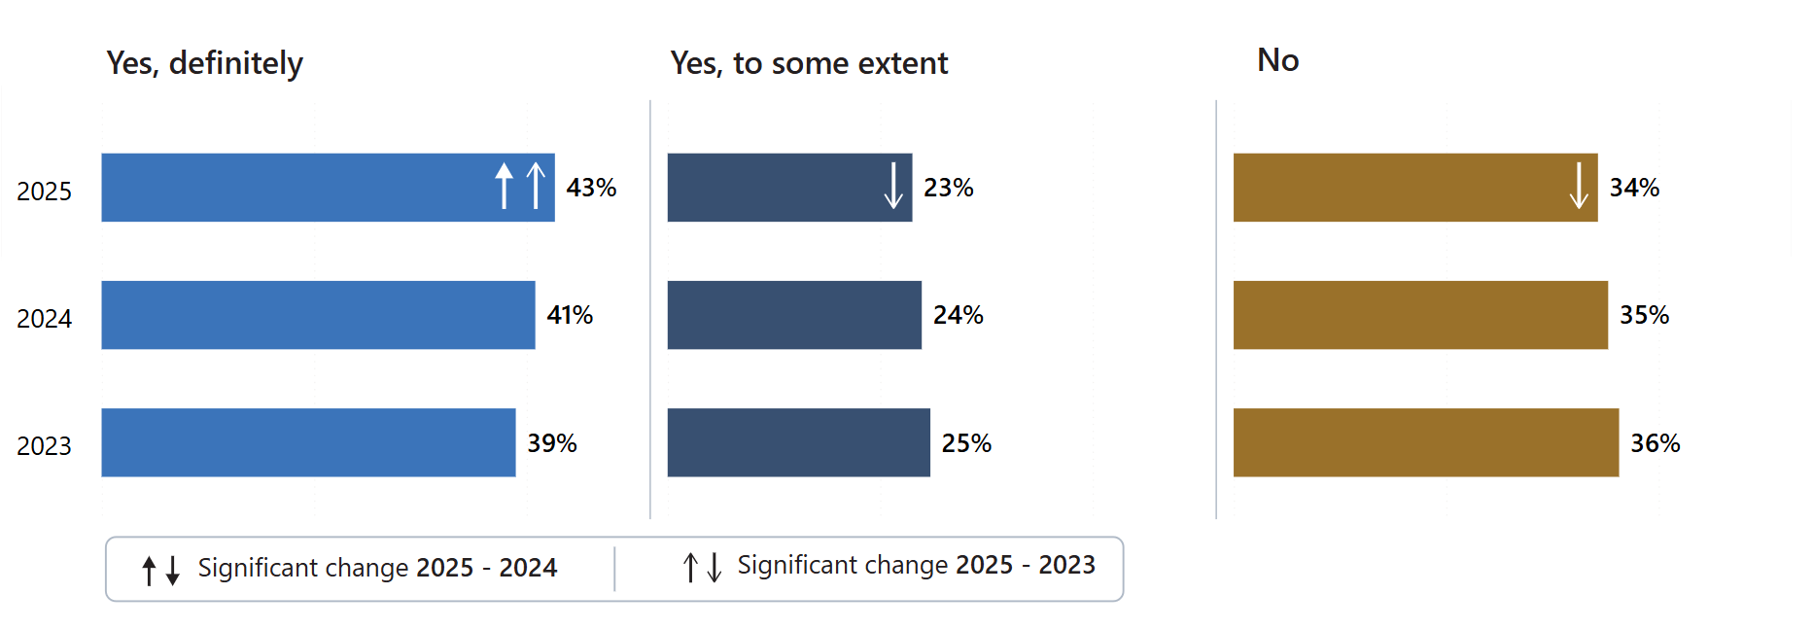
Answered by those who have been receiving any medication in the last 12 months for their mental health needs. Respondents who stated that they didn't know have been excluded. Total number of respondents: (2023) 10,860, (2024) 10,614, (2025) 9,082.

The survey identified that the highest number of respondents who answered ‘yes, definitely’ to whether their medication had been explained to them, was those who had it prescribed by their NHS mental health team (Figure 8). By contrast, respondents were most likely to answer ‘no’ were those who were unsure who had prescribed their medication.

Figure 8: Cross-tabulation between ‘Have any of the following been discussed with you about your medication?... (Q21_1 to _4) and ‘Who prescribed medication for your mental health needs?’ (Q20) showing respondents who answered ‘Yes, definitely’
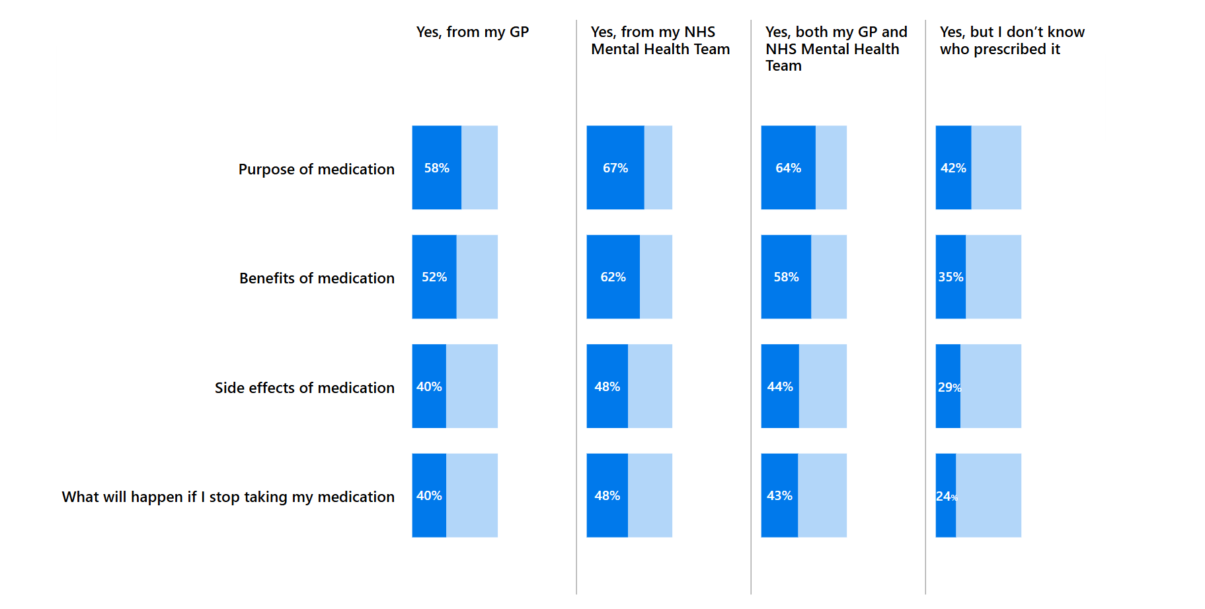
Answered by those who have been receiving any medication in the last 12 months for their mental health needs. Respondents who stated that they didn't know have been excluded from q21_1 to _4 and q20. Total number of respondents: (Q21_1 by q20) 9,807, (Q21_2 by q20) 9,499, (Q21_3 by q20) 9,387, (Q21_4 by q20) 9,001.

4.5 Psychological therapies
Psychological therapies are evidence-based therapies as recommended by NICE and may be offered to some people experiencing mental ill-health. NHS implementation guidance aims to increase access and ensure timely access to evidence-based psychological therapies. People should receive timely access to the assessments, interventions and treatments to ensure therapeutic benefit.

Of those surveyed who wanted therapies for their mental health, 61% had received some in the last 12 months. However, 39% had not but they would have liked it. These percentages are unchanged from 2024. Over half felt the waiting time between their assessment with the NHS mental health team and their first therapy appointment was appropriate (53%), which was a statistically significant increase from 49% in 2024. Forty per cent felt they waited too long, which is a decrease from 44% in 2024 (Figure 9).

Figure 9: How do you feel about the length of time you waited between your assessment with the NHS mental health team and your first therapy appointment? (Q24)
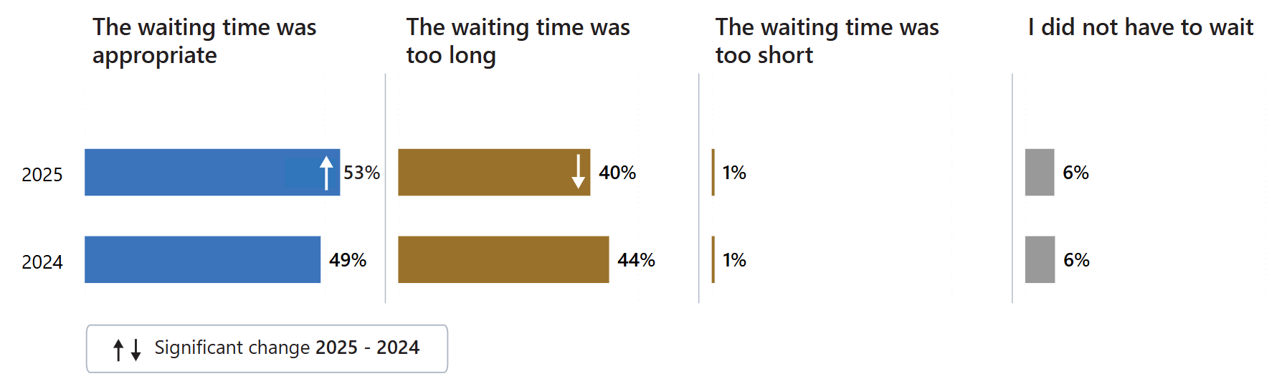
Answered by those who have received any therapy in the last 12 months for their mental health needs. Respondents who stated that they didn't know or couldn't remember have been excluded. Total number of respondents: (2024) 5,673, (2025) 4,871.

4.6 Crisis care access
During periods of mental ill-health, an individual may experience a crisis and will need timely help and access to support. Improving access to mental health crisis care and decreasing waiting times for crisis services are commitments made over many years, including recently in the Fit for the future: 10-year health plan for England.

Respondents were asked if they would know who to contact out-of-office hours within the NHS if they had a crisis. The results show 83% knew who to contact, which was a statistically significant increase on 78% in both 2024 and 2023.

Respondents were then asked if they have contacted NHS mental health crisis support in the last 12 months. Fifty-four per cent had not contacted NHS crisis care, 20% contacted a local crisis service, 18% NHS 111 (option 2) service and 6% a text support service (Figure 10).

Figure 10: In the last 12 months, have you contacted NHS mental health crisis support? (Q27)
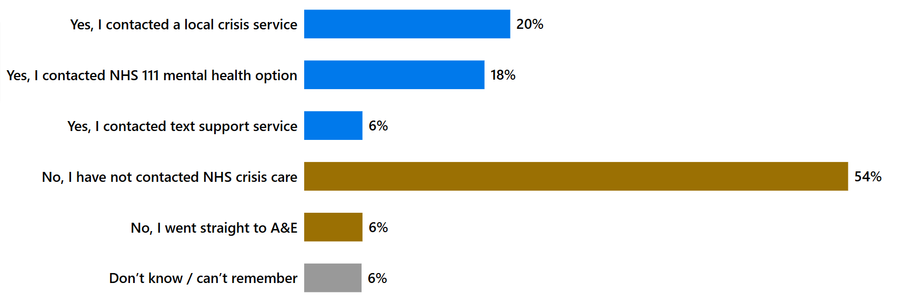
Answered by those who know who to contact out-of-office hours within the NHS if they had a crisis. Multiple response question: percentages may sum to more than 100. Total number of respondents: (2025) 8,778.

Respondents were asked how they felt about the length of time it took to get through to someone the last time they contacted NHS mental health crisis support. Nearly a third of all respondents (32%) reported getting through ‘straight away’, while 1 in 5 (20%) felt they ‘had to wait too long’.

4.7 Crisis care support
When people are in mental health crisis, they need support that is compassionate and meets their needs. Consequently, respondents were asked several questions to understand their experience of crisis care support. They were asked, when thinking about the last time they contacted NHS mental health crisis support, did they get the help they needed. A third (33%) ‘definitely’ got the help they needed, while around the same (32%) did not get the help they needed.

Families and friends may also need support when their loved one is in crisis. However, when asked if the NHS mental health team gave their family or carer information or support while they were in crisis nearly half (45%) said no support or information was provided (Figure 11).

Figure 11: Did the NHS mental health team give your family or carer information or support while you were in crisis? (Q30)
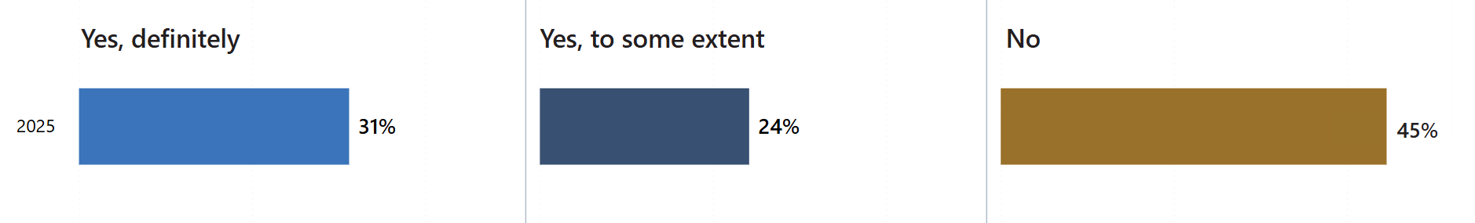
Answered by those who know who to contact out of office hours within the NHS if they had a crisis and have contacted NHS mental health crisis support in the last 12 months. Respondents who stated that their family / carer did not want support or they didn't know or couldn't remember or that this was not applicable to them have been excluded. Total number of respondents: (2025) 2,384.

4.8 Support with other areas of life
Mental ill-health does not occur in isolation. It can be influenced by, and influence, many aspects of a person’s life. These can include housing, financial support, employment, and physical health., Survey respondents were asked a series of questions about the support provided to them in accessing help for their broader needs.

People with a severe mental illness are at higher risk of poor physical health. Policies to address the physical health gap between people with mental ill-health and the wider population have been in place for over a decade., , Consequently, respondents were asked if, in the last 12 months, their NHS mental health team supported them with their physical health needs. ‘Yes, definitely’ was selected by 31% of respondents. There has been no statistically significant change from 2024 or 2023. No support was provided to 38% of respondents though they stated they would have liked it.

Social isolation and loneliness are detrimental to health, with weak social networks and lack of social support associated with higher health risks. To understand the support people using mental health services receive in tackling social isolation and loneliness, the survey asked respondents whether their NHS mental health team gave them any help or advice with finding support for joining a group. Nearly half (45%) of respondents had not received any help or advice, which was a small but statistically significant increase on 2024 (44%).

Stability in both employment and general finances are important elements of maintaining good mental health. Work can contribute to recovery and inclusion and improve confidence and social functioning. The survey asked people who needed support if, in the last 12 months, the mental health team had given them any help or advice with finding support for finding or keeping work. Nearly 7 in 10 (67%) respondents answered ‘no’, which is a statistically significant change on 2024 (69%) and 2023 (70%). Of those that had received support, 16% had ‘definitely’ received help or advice with finding support for finding or keeping work, an increase from 14% in both 2024 and 2023 (Figure 12).

Figure 12: In the last 12 months, did your NHS mental health team give you any help or advice with finding support for…finding or keeping work (Q32_2)

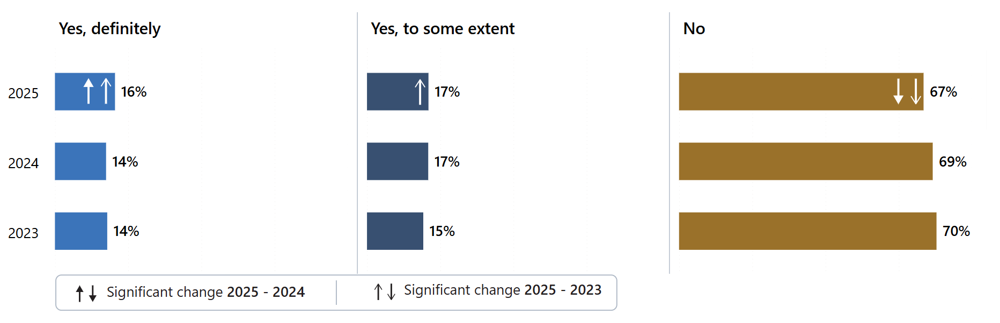
Answered by all. Respondents who stated that they did not need support have been excluded. Total number of respondents: (2023) 8,364, (2024) 8,289, (2025) 6,859.

Subgroup analysis found that disabled people and autistic people reported a poorer experience for receiving help or advice with finding support for joining a group and finding or keeping work. Younger people aged 16-35 and those receiving care via telephone only also reported poorer experiences for finding support for joining a group.

The benefits process can be challenging for people with mental ill-health. Consequently, respondents were asked if, in the last 12 months, their NHS mental health team gave them any help or advice with finding support for help with money or benefits. Two-thirds (66%) of respondents were offered no support, whereas 18% of people were ‘definitely’ offered support. Subgroup analysis identified that those who accessed care face-to-face or had a diagnosis of dementia or Alzheimer’s disease were more likely than average to be given help or advice with finding support with money or benefits.

Support from families and carers, including relatives, friends and non-professional advocates, can be invaluable in making a person feel empowered to deal with their mental health condition. NICE guidance recommends involving family and carers where the person receiving care wishes this.

To understand the involvement of family or friends the survey asked respondents if NHS mental health services involved a member of their family or someone else close to them as much as they would like. Forty-eight per cent felt family or friends were ‘definitely’ involved as much as they would like, which is a statistically significant increase compared with 2024 (45%) and 2023 (45%), whereas 1 in 5 (20%) would like them to be more involved (Figure 13).

Figure 13: Have NHS mental health services involved a member of your family or someone else close to you as much as you would like? (Q33)
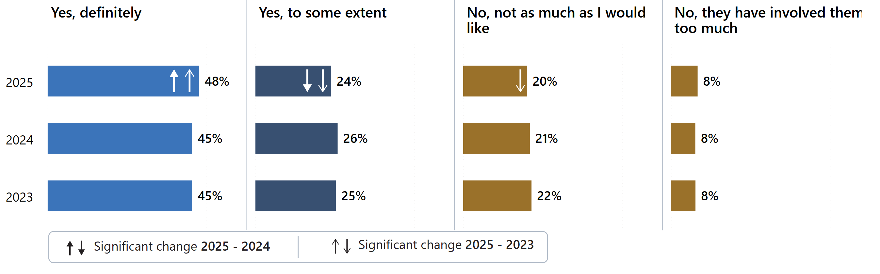
Answered by all. Respondents who stated that this was not applicable to them have been excluded. Total number of respondents: (2023) 10,183, (2024) 9,950, (2025) 8,308.

Subgroup analysis identified that some groups were more likely to report a better than average experience of NHS mental health services involving their family or someone else close to them as much as they would like. These included:
- those aged under 66 years old and older
- people who have been in contact with service for 2 years or less
- people of Muslim faith
- people with dementia or Alzheimer’s disease
- those whose mode of contact was face-to-face
- those who had the survey completed for them by a friend or relative or a health care professional.

4.9 Support in accessing care
Equality of access is enshrined within the Public Sector Equality Duty set out within the Equality Act (2010), which states that organisations including health and social care, such as hospitals and GP surgeries, must take steps to remove the barriers individuals face because of disability. This can take the form of reasonable adjustments, which can include physical modifications, emotional support, delivery changes and accessible information formats. The reasonable adjustment digital flag is currently being rolled out. This national marker indicates the reasonable adjustments a person with a disability may need and ensures this information is visible across all publicly funded health and social care services.

Respondents were asked if their NHS mental health team asked if they needed support to access their care and treatment. Under half of respondents (46%) were asked if they needed support. However, this is a statistically significant increase on 2024 (44%) and 2023 (41%). The number of respondents indicating that they need support has significantly increased by 7 percentage points since 2023, from 28% to 35% in 2025.

Subgroups who reported poorer experiences of their NHS mental health team asking if they needed support to access care and treatment included younger people aged 16 to 35 and those receiving care via telephone, whereas people of Muslim faith reported better than average experiences.

Of those respondents that require support, the 2025 survey asked what support they needed to access their care and treatment. Most respondents (70%) required emotional support, which was a statistically significant decrease from 2024 (74%). Nearly 1 in 4 respondents (24%) required physical support and 28% of respondents required support in accessing online appointments (Figure 14).

Figure 14: What support do you need to access your care and treatment? (Q36)
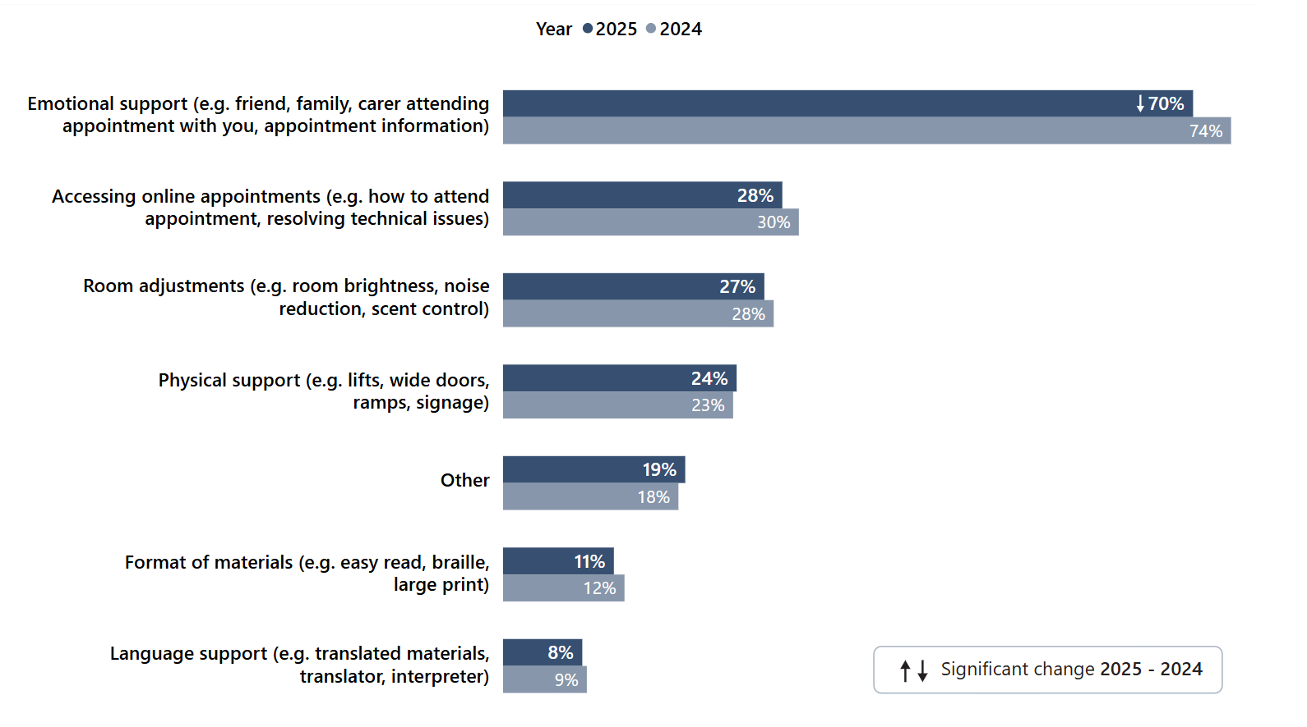Answered by those who needed support to access their care and treatment. Multiple response question: percentages may sum to more than 100. Total number of respondents: (2024), 4,111, (2025) 3,537.

Of those who needed support to access their care and treatment, 31% felt their support ‘completely’ met their needs. However, 23% said it did not meet their needs and a further 11% did not receive support.

4.10 Respect, dignity and compassion
Demonstrating respect, dignity and compassion is fundamental to fostering constructive and trusting relationships between those delivering mental health services and those receiving care. People should expect to be treated with compassion, dignity and respect as a basic human right, as highlighted in the NHS Constitution values. Furthermore, the NICE quality statement 1: Empathy, dignity and respect acknowledges all 3 as important components of positive experiences.

Respondents were asked if their NHS mental health team treated them with care and compassion and, in a second question, if they were treated with respect and dignity. A statistically significant increase was observed in respondents who reported they were ‘always’ treated with care and compassion (65% in both 2023 and 2024 to 67% in 2025). Similarity, 66% were ‘always’ treated with respect and dignity, which was a statistically significant increase from 2024 (65%). However, 1 in 10 (10%) people who use services said they were not treated with respect and dignity.

Subgroup analysis found worse than average experiences for those aged 16 to 50 when it came to being treated with ‘respect and dignity’ and ‘care and compassion’ along with:
- those whose mode of contact was over the telephone
- people in contact with NHS mental health services for 6 years or more
- disabled people
- those who have had an inpatient stay in the last 12 months
- autistic people.

Among other groups, men reported a better than average experience for being treated with respect and dignity, as well as those of Christian faith.

4.11 Overall experience
The common principles and values of the NHS, as set out in the NHS Constitution, includes the commitments to place people who use services at the heart of everything the NHS does, and provide quality care that is focused on patient experience.

Respondents were asked to rate their experience of using NHS mental health services on a scale of 0 to 10, with 0 indicating very poor experiences and 10 indicating very good experiences. A score of 0 was given by 9% of respondents, a figure that has remained consistent since 2023 (Figure 15). The top 2 response options (9 and 10) were given by 36% of those using services.

Figure 15: Overall, in the last 12 months, how was your experience of using NHS mental health services? (Q38) Answers given on a scale of 0 to 10, where 0 means respondent had a very poor experience and 10 means respondents had a very good experience.
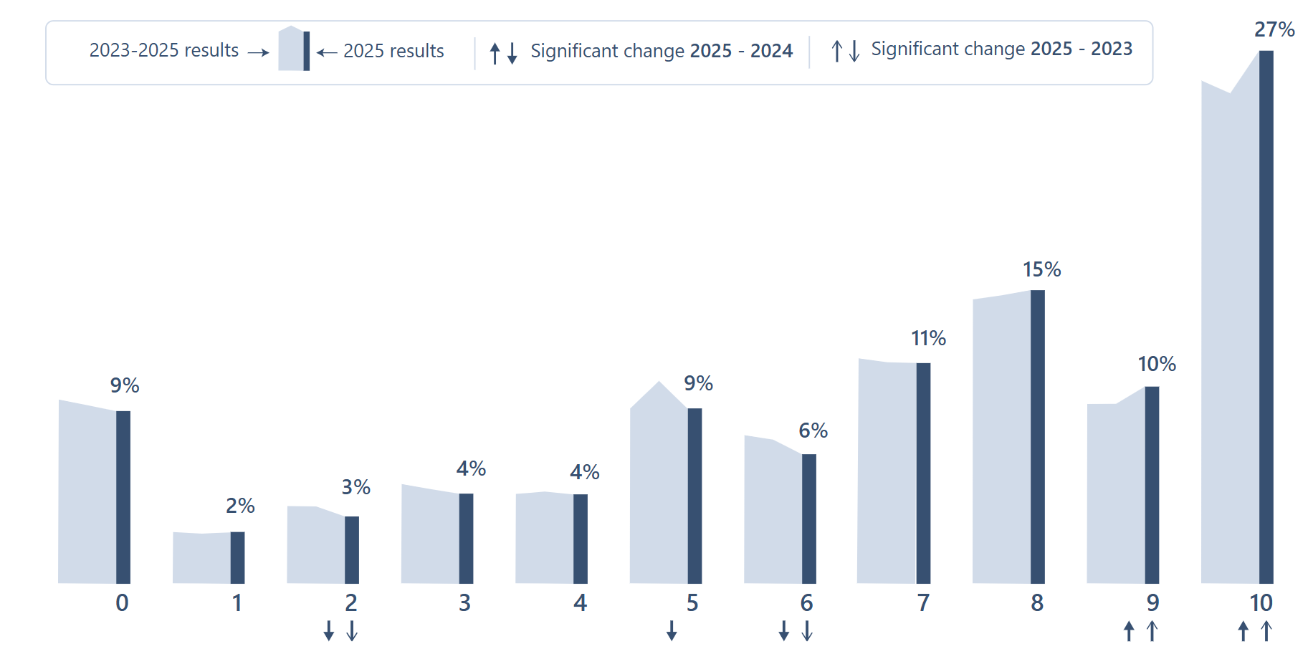
Answered by all. Total number of respondents: (2023) 14,254, (2024) 14,112, (2025) 11,893.

Similar to subgroup analysis results for specific areas of care, those aged 16-50, those receiving care via the telephone, disabled people, and autistic people reported a poorer than average overall experience, as did people with a neurological condition and those receiving care via multiple modes.

4.12 Feedback
The NHS Constitution actively encourages feedback from the public, patients and staff so the NHS can use it to improve its services. CQC data supports NHS England to track progress on people’s experiences and feedback, and to understand where inequality is present and the impact that policy initiatives are having on people who use services.

Respondents were asked, apart from this questionnaire, whether in the last 12 months, they have been asked by NHS mental health services to give their views on the quality of their care. Compared with 2024, there was a statistically significant increase of 2 percentage points in the proportion of respondents who had been asked, and a 3-point increase since 2023, rising from 27% to 30%. Seventy per cent of respondents had not been asked for their views (Figure 16).

Figure 16: Aside from this questionnaire, in the last 12 months, have you been asked by NHS mental health services to give your views on the quality of your care? (Q40)
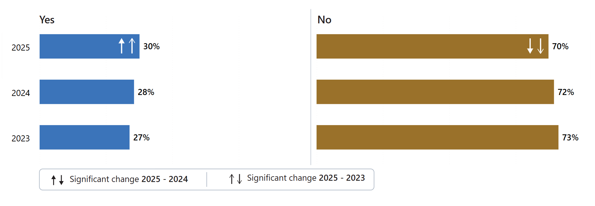
Answered by all. Respondents who answered that they were not sure have been excluded. Total number of respondents: (2023) 12,102, (2024) 11,557, (2025) 9,730.

5. Results for individual assessment service groups (ASG)
In this section the findings from the survey for the individual assessment service groups (ASGs) are presented. Specifically, children and young people’s mental health services (CYPMHS), and older people’s mental health services. Adult mental health services are not addressed separately as the 2025 results largely reflect the national findings. Any statistically significant changes between 2025 to 2024 and 2025 to 2023 for adult mental health services that differ from the national results have been flagged within the national results section footnotes.

The older people’s mental health services and CYPMHS ASG results are presented separately to the national results due to the low response rates, particularly for the CYPMHS data. Consequently, comparisons will not be drawn between the groups or against the national results. However, these results build on the insights from the 2023 and 2024 surveys into the experience of mental health services from the perspective of different service groups and where possible, comparisons between years will be made within the ASG.

5.1 Children and young people’s mental health services (CYPMHS)

Section 3.7 of this report, on Mental health support for young people, emphasises that mental health issues in adulthood frequently stem from childhood or young adulthood, highlighting the critical need for timely intervention. Children and young people access NHS mental health support through Children and young people’s mental health services (CYPMHS). Support within this service is provided until the individual reaches 25, however, people can start transitioning to adult mental health services (AMHS) from the age of 16.

The 2025 Community mental health survey included the views of 16 to 18-year-olds who were receiving specialist care or treatment for a mental health condition between 1 April and 31 May 2025. In line with the national findings, the experiences of people using CYPMHS are discussed across a range of themes.

Support while waiting
Forty-six per cent of respondents waited 3 months or more for their first appointment for treatment. To explore waiting times further, the survey asked a series of questions about respondents’ experiences during this period.

Firstly, respondents were asked if they experienced any changes in their mental health while waiting. The 2025 survey identified that just under half (46%) of young people found their mental health got worse while waiting. However, compared with the 2023 results (60%) this is a statistically significant improvement (Figure 17). When compared with how long respondents waited between their assessment and first appointment for treatment, the highest proportion who saw a decline in their mental health was among those who had waited 6 months or more (65%).

Figure 17: While waiting, between your assessment with the NHS mental health team and your first appointment for treatment, did you experience any changes in your mental health? (Q5)
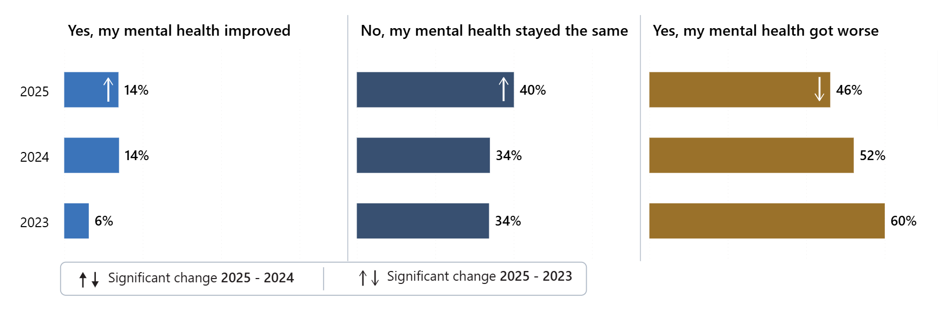
Answered by those who have been in contact with the NHS mental health services for the past 2 years. Respondents who stated that they didn't know or couldn't remember have been excluded. Total number of respondents: (2023) 546, (2024) 533, (2025) 450.

Respondents were also asked if they were offered support while waiting between their assessment with the NHS mental health team and their first appointment for treatment. Over a half (54%) were not offered any support.

Respondents who said they were offered support while they waited for treatment were asked whether they felt the support they were offered was appropriate for their mental health needs. Just under 1 in 3 (31%) people said the support offered was ‘completely’ appropriate for their needs.

Mental health team
Discussing mental health can be challenging for children and young people, often due to concerns about not being taken seriously, not being understood, or previous negative experiences. It is therefore essential that they feel comfortable with their mental health team. A supportive, trusting relationship enables young people to discuss their care, mental health, and wider circumstances. Achieving this requires sufficiently long appointments and a coordinated approach, despite rising service pressures.

To understand people’s experiences of their mental health team, respondents were asked if they were given enough time to discuss their needs and treatment during their appointments. Just under half (44%) of people using CYPMHS said they were ‘definitely’ given enough time to discuss their needs and treatment – a statistically significant increase from 39% in 2023. However, nearly 1 in 5 (18%) responded ‘no’ they did not have enough time. They were then asked if their mental health team listened to what they had to say and 44% reported their mental health team ‘always’ listened.

People were asked if they got the help they needed. Over 1 in 4 (26%) said ‘no’ (Figure 18). This was a statistically significant change from 2023 (30%) and 2024 (31%).

Figure 18: Did you get the help you needed? (Q10)
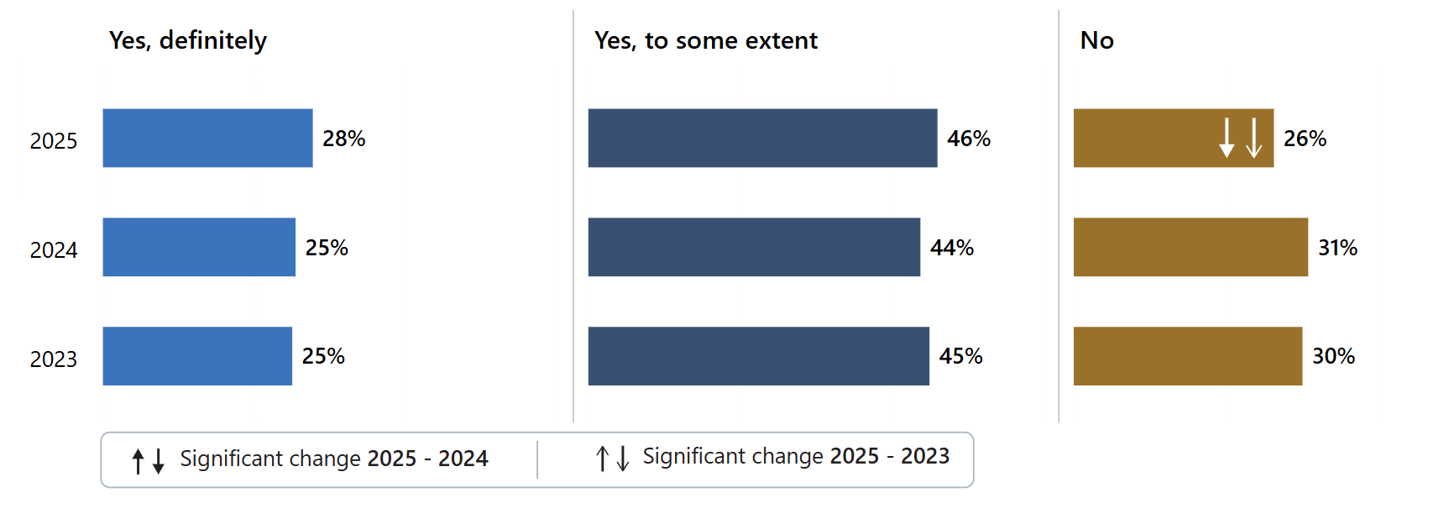
Answered by all. Respondents who stated that they didn't know or couldn't remember have been excluded. Total number of respondents: (2023) 1,240, (2024) 1,329, (2025) 1,089.

The 2025 survey asked people if their mental health team told them who to contact if they had any questions or concerns about their care or treatment. Just under a quarter (24%) of respondents had not been told.

Your care
There should be active participation with people using services in treatment decisions, which supports self-management. It is essential to involve children and young people and their families (and when it’s appropriate, those who care for them) in every aspect of their care. Engaging with children and young people involves understanding their views and working with them to shape care that meets their needs.

To understand people’s involvement in decision making, people were asked if their NHS mental health team had involved them in a plan for their care. Just under two-fifths (39%) said they were ‘completely’ involved, whereas 26% had no plan or were not aware of a plan.

When asked if they were given a choice on how their care and treatment would be delivered, for example in person, via video call, by telephone, online course or digital apps, 67% said they were.

Care review meetings are critical in understanding how the person is getting on with their treatment, any new or additional needs, and to resolve any difficulties. Consequently, the survey asked if, in the last 12 months, they have had a care review meeting with their NHS mental health team to discuss how their care is working. Forty-five per cent of respondents said they had not had a care review meeting.

Understanding the risks and benefits of care and treatment is important in making informed decisions about care. The 2025 survey also asked people if their NHS mental health team supported them to make decisions about their care and treatment. About 1 in 4 (24%) said they had not been supported. However, there was a statistically significant increase in the proportion of people who felt they were ‘definitely’ supported in 2025 (40%), compared with 2024 (34%) (Figure 19).

Figure 19: Has your NHS mental health team supported you to make decisions about your care and treatment? (Q18)
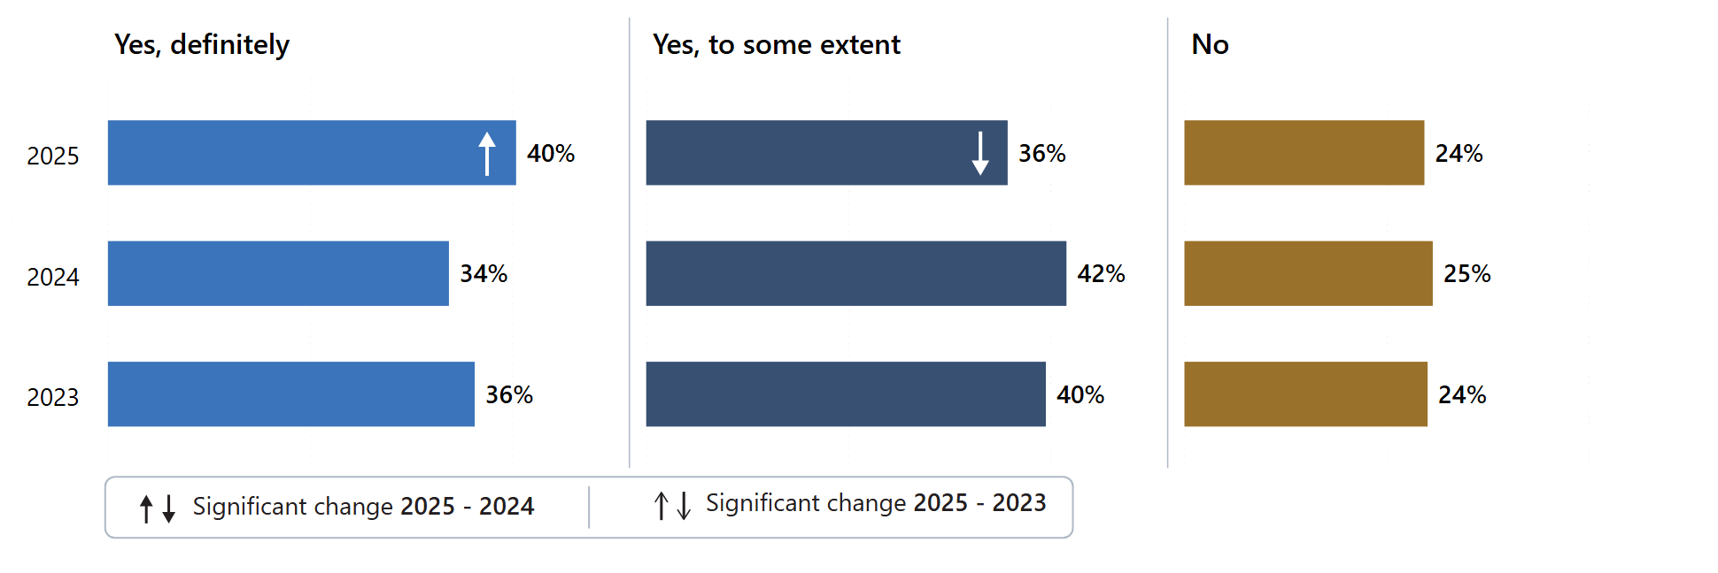
Answered by all. Respondents who stated that they didn't know or couldn't remember have been excluded. Total number of respondents: (2023) 1,157, (2024) 1,216, (2025) 1,004.

Respondents were also asked if they have been given a diagnosis for their mental health. The largest proportion of respondents who had been in contact with services for less than a year reported having received no diagnosis (60%). For respondents who had been seen for over 10 years, 85% had received a diagnosis. The largest proportion of respondents having a change in their diagnosis was observed in people being seen for 6 to 10 years (10%).

Medication
Sometimes medicines form part of the plan to help a young person. The survey found that 59% of respondents were receiving medication for their mental health needs. Medication was mostly prescribed by the NHS mental health team (25%).

For those respondents that were prescribed medication, the survey asked respondents using CYPMHS aged 16 and over a series of 4 questions about what aspects of their medication had been discussed with them.

The purpose of their medication had ‘definitely’ been discussed with nearly 3 in 4 (73%) of respondents. The benefits of their medication had ‘definitely’ been discussed with 68% of respondents, which is an increase from 61% compared with 2023. When asked if the side effects of their medication had been explained, 3 in 5 (60%) of respondents had ‘definitely’ discussed this, which is an increase on 52% in 2024 and 53% in 2023. Lastly, when asked if they had discussed what would happen if they stopped taking their medication 30% responded ‘no’ they had not had this discussion, which is a statistically significant change from 2023 (39%) and 2024 (37%) (Figure 20).

Figure 20: Have any of the following been discussed with you about your medication? What will happen if I stop taking my medication. (Q21_4)
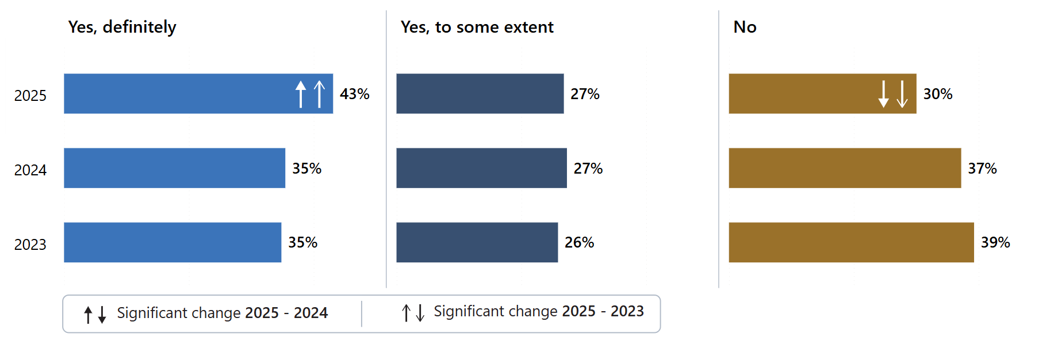
Answered by those who have been receiving any medication in the last 12 months for their mental health needs. Respondents who stated that they didn't know have been excluded. Total number of respondents: (2023) 740, (2024) 745, (2025) 616.

The survey also asked if, in the last 12 months, their NHS mental health team asked them how they are getting on with their medication. Eighty-eight per cent of people said ‘yes’ and there is no statistically significant change between 2023 (86%) or 2024 (86%).

Psychological therapies
Sixty-nine per cent of respondents reported having received any therapies for their mental health needs. For these CYPMHS respondents who had received therapies in the last 12 months, the survey asked how they felt about the length of time they waited between their assessment with the NHS mental health team and their first therapy appointment. Just over two-fifths (42%) said that the waiting time was appropriate which is a statistically significant increase on 2024 (34%). However, 50% felt that the waiting time was too long, though this is a decrease compared with 59% in 2024 (Figure 21).

Figure 21: How do you feel about the length of time you waited between your assessment with the NHS mental health team and your first therapy appointment? (Q24)
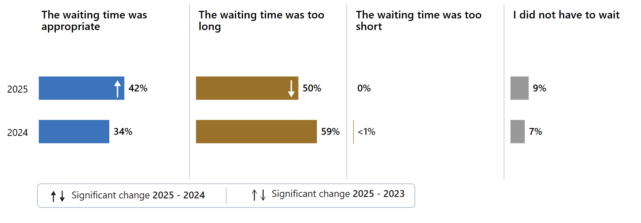
Answered by those who have received any therapy in the last 12 months for their mental health needs. Respondents who stated that they didn't know or couldn't remember have been excluded. Total number of respondents: (2024) 695, (2025) 552.

The survey asked if, during the last time respondents received therapy, they had enough privacy to talk comfortably. In response, 73% of those using CYPMHS said ‘yes, definitely’. This was a statistically significant increase from 2024 (67%).

Crisis care – access and support
Respondents were asked if they would know who to contact out-of-office hours within the NHS if they had a crisis. Just under a third (31%) reported that they would not know who to contact in a crisis, which was a statistically significant change from 2023 (38%) (Figure 22).

Figure 22: Would you know who to contact out-of-office hours within the NHS if you had a crisis? (Q26)
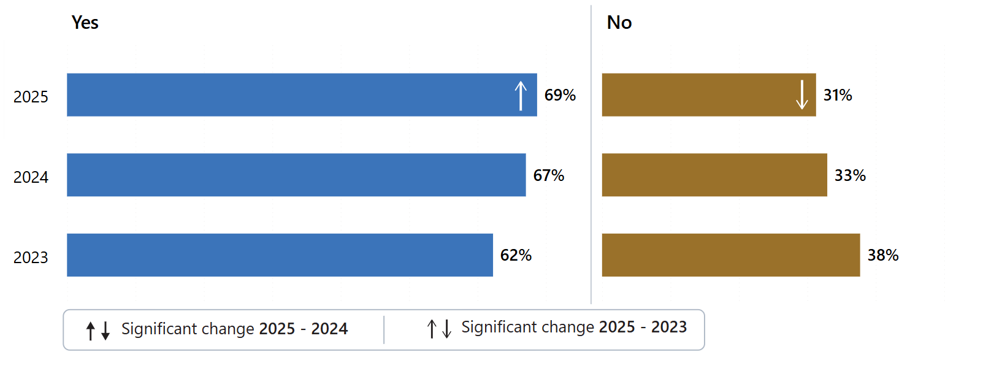
Answered by all. Respondents who stated that they were not sure have been excluded. Total number of respondents: (2023) 1,091, (2024) 1,185, (2025) 967.

Those who knew who to contact when in crisis were asked how they have made contact. The highest proportion of respondents (14%) accessed crisis services via the NHS 111 mental health option. Thirteen per cent went straight to A&E and 11% contacted a local crisis service. Of those who accessed crisis care support over 1 in 4 (27%) had to wait too long to get through and over half (51%) of respondents did not receive the help they needed.

Support with other areas of life
Mental ill-health does not occur in isolation. It can be influenced by, and influence, many aspects of a person’s life. Therefore, people requiring support were asked several questions about the NHS support provided to them in accessing help for their broader needs.

First, respondents were asked whether, in the last 12 months, their NHS mental health team supported them with their physical health needs. There has been a statistically significant decrease in the percentage of respondents answering ‘yes, definitely’ down to 26% from 32% in 2023, whereas over a third (36%) answered ‘no’ (Figure 23).

Figure 23: In the last 12 months, has your NHS mental health team supported you with your physical health needs? (Q31)

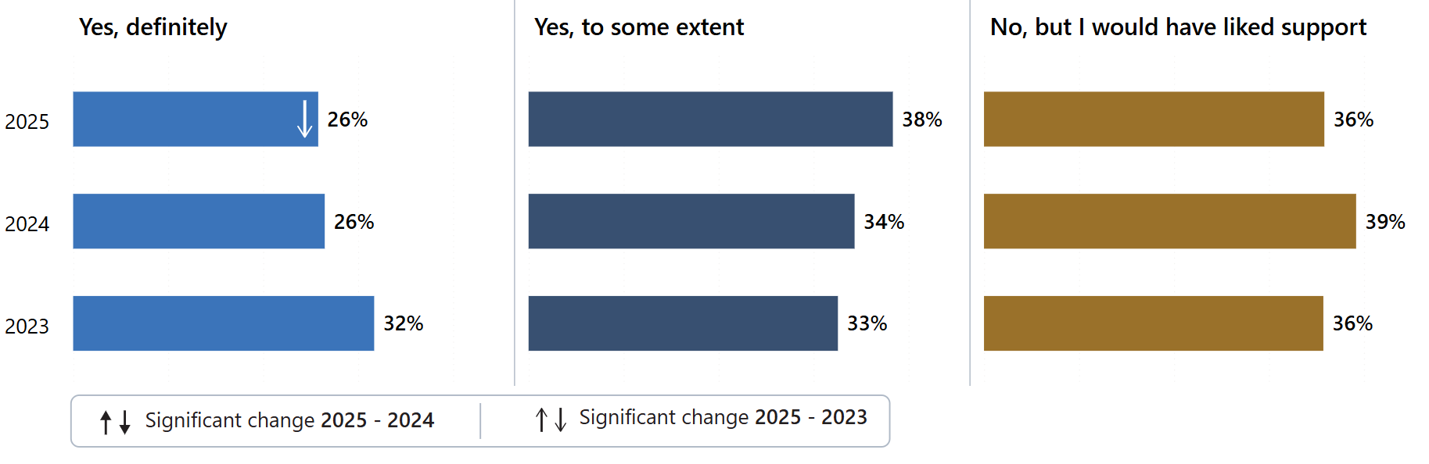Answered by all. Respondents who stated that they had support and did not need this, did not need support or did not have physical health needs have been excluded. Total number of respondents: (2023) 546, (2024) 670, (2025) 495.

Respondents were also asked further questions about wider support. Firstly, if in the last 12 months, their NHS mental health team gave them any help or advice with finding support for joining a group. Nearly two-thirds of respondents (62%) received no help or advice. Just over 1 in 10 (12%) stated they ‘definitely’ received support, which is a statistically significant decrease compared with 2024 (16%) and 2023 (18%) (Figure 24).

Figure 24: In the last 12 months, did your NHS mental health team give you any help or advice with finding support for…Joining a group (e.g. art, sport etc). (Q32_1)
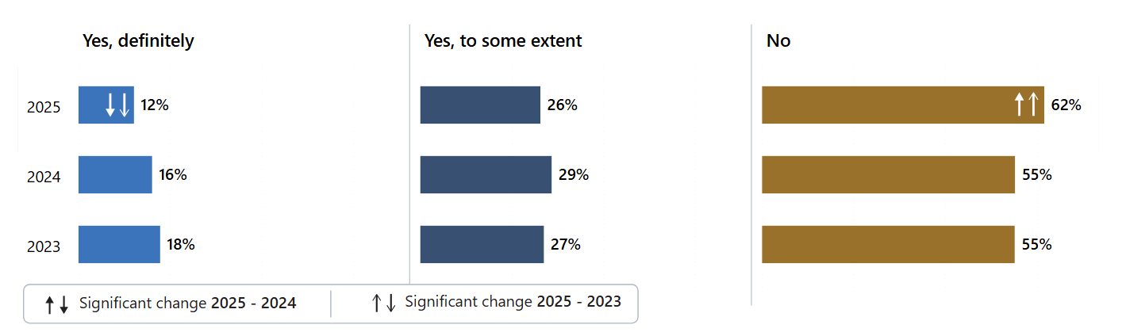
Answered by all. Respondents who stated that they did not need support have been excluded. Total number of respondents: (2023) 1,032, (2024) 1,092, (2025) 835.

Respondents were then asked if they had received any help or advice with finding support for finding or keeping work. The majority (80%) of respondents received no help or advice. Six per cent ‘definitely’ received support, which is a statistically significant decrease compared with 2023 (9%).

In an amended question for 2025, respondents were asked if they had help or advice in finding support for help with money or benefits. The majority (84%) received no help or advice.

Family and carer involvement is linked to better mental health outcomes, fewer relapses and improved engagement with treatment. Therefore, the 2025 survey asked whether NHS mental health services involved a member of their family or someone else close to them as much as they would like. Over half (54%) said ‘yes, definitely’ which is a statistically significant increase compared with 2024 (49%).

Support in accessing care
Seventy-one per cent of respondents reported not needing support to access their care. However, the number requiring support (29%) has shown a statistically significant increase compared with 2023 (22%).

Respondents were asked if their NHS mental health team asked if they needed support to access their care and treatment. Nearly 2 in 3 (62%) respondents using CYPMHS were not asked if they required support to access their care and treatment.

Those individuals who needed support to access their care were asked what support they required. Most respondents (81%) required emotional support, followed by room adjustments (36%) which shows a statistically significant reduction compared with 2024 (47%).

Respondents who had received support were asked whether the support provided met their needs. Sixty-one per cent said it met their needs ‘completely’ or ‘to some extent’.

Respect, dignity and compassion
Respondents were asked if their NHS mental health team treated them with care and compassion. Nearly two-thirds (63%) of people reported that they were ‘always’ treated with care and compassion, a statistically significant increase from 59% in 2024 and 56% in 2023. A slightly lower proportion (59%) reported they were ‘always’ treated with respect and dignity. However, nearly 1 in 10 (8%) said they were not treated with dignity and respect, though this represents a statistically significant improvement from 11% in 2023.

Overall experience
Respondents were asked to rate their experience of using NHS mental health services on a scale of 0 to 10, with zero indicating a very poor experience and 10 indicating they had a very good experience. Of those using CYPMHS, over 1 in 5 people (22%) assigned a score of 9 or 10 to their experience. This figure is in line with 2024 and 2023.

Transitioning to adult services
The survey asked if in the last 6 months had they moved from children and young people's services to adult mental health services. Eighty-eight per cent had not moved in the last 6 months. Response rates were too low for these transition questions (X2 to X5) to be reported.

5.2 Older people’s mental health services
Older people’s mental health services typically support adults aged 65 and over. Through integrated primary and community care models, these services aim to give older adults greater choice and control over their care. As part of ongoing transformation, staff in older people’s mental health services are also expected to work closely with physical health teams to ensure more coordinated support.

Support while waiting
NICE Quality Statement 3 highlights that ageing with good mental health can make a significant difference in ensuring that life is enjoyable and fulfilling. Consequently, when a person is experiencing mental ill-health, timely support is important.

The 2025 responses indicate that nearly 1 in 3 people (29%) waited less than 2 weeks for their first treatment appointment, a statistically significant increase compared with 2024 (24%) and 2023 (21%). The proportion waiting 6 months or more has remained stable at 7%, showing no statistically significant change.

Respondents were asked, if while they waited, whether they experienced any changes in their mental health. The 2025 survey found there was a statistical increase in the number of respondents that felt their mental health improved while waiting, from 11% in 2023 to 15% in 2025. Nearly a third of respondents (30%) said their mental health got worse.

While waiting between their assessment with the NHS mental health team and their first appointment for treatment, 1 in 3 (34%) people were not offered support with their mental health. However, 66% were offered support, which is a statistically significant increase when compared with 2024 (58%) and 2023 (61%). Ninety-five per cent felt the support offered was appropriate ‘completely’ or ‘to some extent’.

Mental health team
NICE guidance describes that those who use services should be able to talk about their experiences of care, mental health, and other aspects of their lives by developing a therapeutic relationship with their mental health team. This will require appointments being of sufficient duration and being able to express concerns and consider wider needs.

In the 2025 survey, respondents were asked if they were given enough time to discuss their needs and treatment during their appointments. Sixty-nine per cent were given enough time, which is a statistically significant increase compared with 2023 (66%). When asked if they felt their NHS mental health team listened to what they had to say, 3 in 4 (75%) respondents answered ‘yes, always’. However, almost 1 in 10 (9%) felt that they did not get the help they needed.

Respondents were also asked if their NHS mental health team considered how areas of their life impact their mental health. Fifty-eight per cent answered ‘yes, definitely’. This was a statistically significant increase compared with 2024 (55%) and 2023 (54%). However, nearly 1 in 10 (9%) did not have other areas of their life considered.

Most respondents (90%) reported that their mental health team had told them who to contact if they had any questions or concerns about their care or treatment.

Your care
To understand planning and people’s involvement in decision-making, respondents were asked a series of questions. Firstly, people using older people’s mental health services were asked if their NHS mental health team involved them in a plan for their care. Half (50%) of respondents were ‘completely’ involved; however, 1 in 5 (20%) were not involved or were not aware of a plan for their care.

Respondents were then asked if they were given a choice on how their care and treatment would be delivered. Almost 1 in 4 (24%) were not given a choice but this represents a statistically significant improvement from 2024, when 29% said the same.

Care plans should be reviewed regularly. A review every 12 months should monitor progress and changes, consider how the care is meeting needs and determine what might be needed in the future. The 2025 survey shows a statistically significant rise in the proportion of respondents who had a care review meeting in the past 12 months, increasing to 72% in 2025 from 67% in both 2024 and 2023.

Respondents were also asked whether they felt supported to make decisions about their care and treatment. Just over half (55%) reported that they were ‘definitely’ supported, marking a statistically significant increase from 50% in 2024 and 49% in 2023. Thirteen per cent said they were not supported, although this represents an improvement compared with 2024 and 2023, when 16% reported the same.

Medication
To help understand an individual’s motivations for taking, or not taking medicines, as well as to increase overall compliance, guidance produced by NICE recommends that people who use services are included in decisions about prescribed medicines. The 2025 survey sought to understand whether the purpose of their medication, the benefits and the side-effects were explained to people using services and whether people were being asked how they are getting on with their medication.

Eighty-eight per cent of respondents indicated that they had been receiving medication for their mental health needs. Nearly 1 in 10 (8%) had not discussed the purpose of their medication with their mental health team, a statistically significant increase from 6% in both 2024 and 2023. The benefits of a person’s medication were ‘definitely’ discussed with 63% of respondents. However, 1 in 10 (10%) respondents had not had this discussion, which was a statistically significant increase compared with 2023 (8%) (Figure 25).

Figure 25: Have any of the following been discussed with you about your medication? Benefits of medication (Q21_2)
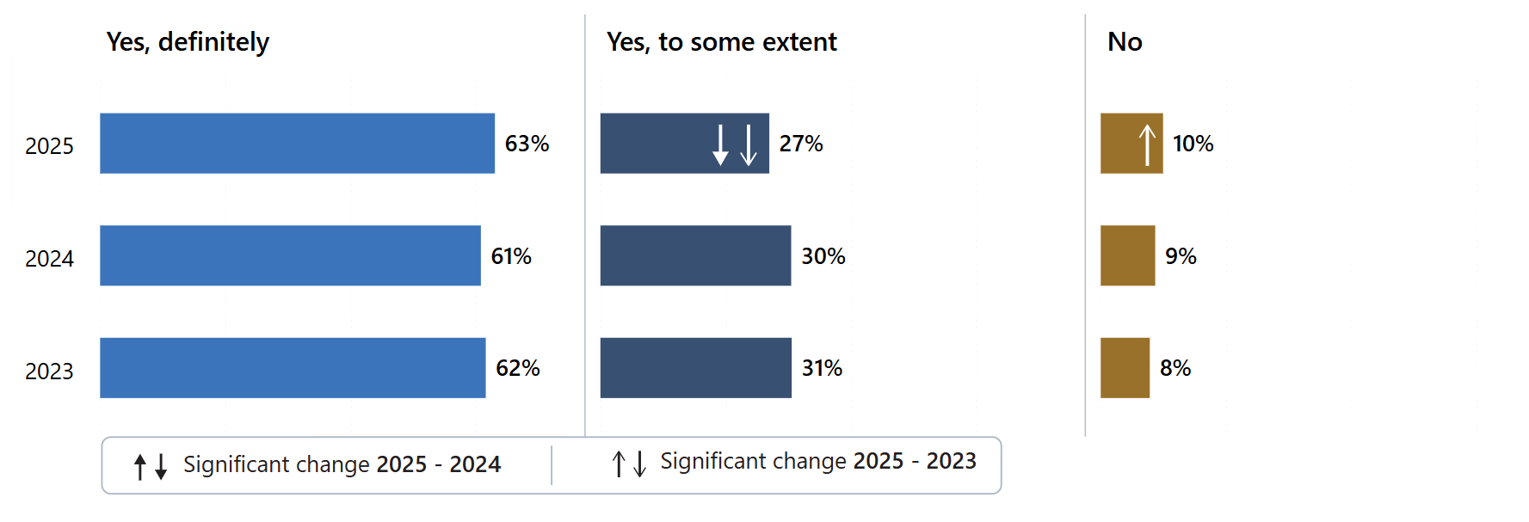
Answered by those who have been receiving any medication in the last 12 months for their mental health needs. Respondents who stated that they didn't know have been excluded. Total number of respondents: (2023) 1,683 (2024) 1,584, (2025) 1,373.

A quarter (25%) had not discussed the side-effects of their medication. Furthermore, 31% had not had a discussion about what would happen if they stopped taking their medication. However, 83% had been asked by their NHS mental health team how they are getting on with their medication in the last 12 months.

Psychological therapies
Respondents were asked if they had received therapies for their mental health needs in the last 12 months. Sixty-two per cent of respondents received therapies, however, 38% of respondents had not received therapies but would have liked this. Where respondents had received NHS psychological therapies, the survey asked how they felt about the length of time they waited between their assessment with the NHS mental health team and their first therapy appointment. One in five (20%) felt that the waiting time was too long.

The survey then asked respondents if they had enough privacy to talk comfortably. In response, 86% of those using older adult services ‘definitely’ felt they had enough privacy.

Crisis care support and access
Improving access to mental health crisis care and decreasing waiting times for crisis services are commitments made in the Five Year Forward View Implementation Plan, the NHS Long Term Plan and recently in the 10-year health plan for England.

To understand crisis care access and support, respondents were asked if they would know who to contact out-of-office hours within the NHS if they had a crisis. Just over four-fifths (81%) knew who to contact, which is a statistically significant increase compared with both 2024 (74%) and 2023 (71%). Thirty-one per cent contacted NHS mental health crisis support, with 12% via the NHS 111 mental health option. Five per cent did not contact crisis support but went straight to A&E.

Respondents who had contacted NHS mental health crisis support were asked about the time it took to get through. Almost half (47%) got through straightaway, while 10% felt they waited too long and 2% did not get through at all. In addition, 14% reported that they did not receive the help they needed.

Support with other areas of life
Mental ill-health does not occur in isolation; it is shaped by many aspects of a person’s life, including housing, finances, employment and physical health. To understand the support people receive in these areas, the survey asked respondents a series of questions about the help provided to them with their wider needs. Those who already had active support or felt they did not require support with their needs were excluded from results.

Respondents were first asked whether, in the past 12 months, their NHS mental health team had supported them with their physical health needs. Among those using older people’s mental health services, almost a quarter (24%) said they had not received this support but would have liked it.

Respondents were then asked a series of 3 further questions about support in other areas of their life. When considering if, in the last 12 months, their NHS mental health team gave them any help or advice with finding support for joining a group, 35% received no help or advice.

Finding work is increasingly relevant for older people – in part due to the rising pension age and financial pressures. Therefore, the survey asked if, in the last 12 months, their NHS mental health team gave them any help or advice with finding or keeping work. There was a statistically significant 4 percentage point drop in respondents answering ‘no’ they had not received help or advice, from 90% in 2023 to 86% in 2025.

The third question in the series asked whether their NHS mental health team gave them any help or advice with finding support for help with money or benefits. Sixty-five per cent received no help.

Respondents using older people’s mental health services were asked about the involvement of family or someone else close to them. Just over two-thirds (68%) ‘definitely’ felt their NHS mental health services had involved a member of their family or someone else close to them as much as they would like. This is a statistically significant increase compared with 2024 (63%). Four per cent felt they were involved too much.

Support in accessing care
Respondents were asked whether their NHS mental health team had checked if they needed support to access their care and treatment. Just over half (56%) of those using older people’s mental health services said they had been asked, which is a statistically significant increase from 52% in 2024 and 51% in 2023. Among the 29% who required support, 40% reported that their needs were fully met, while just over 1 in 7 (15%) said their support needs were not met.

The 2025 survey asked respondents what support they needed to access their care and treatment. Most required emotional support (70%) – a statistically significant decrease from 76% in 2024. This was followed by physical support (36%) and support with accessing online appointments (29%).

Respect, dignity and compassion
Respondents were asked whether their NHS mental health team treated them with care and compassion. The majority of those using older adult mental health services (85%) reported they were ‘always’ treated with care and compassion, which is a statistically significant increase from 82% in 2024. Similarly, 86% said they were ‘always’ treated with respect and dignity, also reflecting a significant increase from 82% in 2024.

Overall experience
Respondents were asked to rate their experience of using NHS mental health services on a scale of 0 to 10, with 0 indicating very poor experiences and 10 indicating very good experiences. When aggregated, over half (54%) of people using older people’s mental health services gave an overall score of 9 or 10. This is a statistically significant increase compared with 2024 (50%) and 2023 (49%).

6. Subgroup analysis summary: how experience varies for different groups of respondents
Both the NHS Constitution and the Equality Act 2010 require providers of healthcare services to equally consider the needs, experiences, outcomes and aspirations of people with protected characteristics under equalities law.

This section shows the results of a ‘subgroup analysis’, which considers the experiences of different groups of people. Looking at the questions asked within the survey, the analysis models the average probability of different groups of people using community mental health services selecting the most positive answers to questions or sets of questions according to demographic, health, and care characteristics.

These characteristics are:
- Age
- Sex
- Gender different to sex
- Ethnicity
- Religion
- Sexual orientation
- Mode of contact (e.g. face-to-face, video conferencing, telephone)
- Index of Multiple Deprivation decile (IMD)
- Length of contact with mental health services
- Long-term conditions
- Disability
- Proxy response – whether the questionnaire was completed entirely by, or with the support of, someone other than the person who used the services.
- Mental health inpatient – whether the respondent had a mental health inpatient stay within the last 12 months.

There were no differences in experience found for the index of multiple deprivation (IMD); therefore, this subgroup has not been included in the tables that follow in this section.

Please refer to the subgroup report on the 2025 Community mental health survey webpage for more information about the questions used, as well as the charts.

In this report, subgroup differences are considered reportable where a demographic or care characteristic overall (for example, age) is significantly associated with experience and where the mean response for the specific subgroup (for example, people aged 16 to 35) is significantly different from the overall mean. For further technical information on the subgroup analysis, please see the Quality and methodology report.

Questions included in the subgroup analysis
Q8: Were you given enough time to discuss your needs and treatment?
Q9: Did you feel your NHS mental health team listened to what you had to say?
Q10: Did you get the help you needed?
Q11: Did your NHS mental health team consider how areas of your life impact your mental health?
Q12: Did you have to repeat your mental health history to your NHS mental health team?
Q13: Did your mental health team tell you who to contact if you had any questions or concerns about your care or treatment?
Q14: Did your NHS mental health team treat you with care and compassion?
Q15: Did your NHS mental health team involve you in a plan for your care?
Q16: Were you given a choice on how your care and treatment would be delivered?
Q17: In the last 12 months, have you had a care review meeting with your NHS mental health team to discuss how your care is working?
Q18: Has your NHS mental health team supported you to make decisions about your care and treatment? Support includes sharing information on risks and benefits of your care and treatment.
Q19: Have you been given a diagnosis for your mental health?
Q26: Would you know who to contact out-of-office hours within the NHS if you had a crisis?
Q31: In the last 12 months, has your NHS mental health team supported you with your physical health needs (this might be an injury, a disability, or a condition such as diabetes, epilepsy, etc)?
Q32_1: In the last 12 months, did your NHS mental health team give you any help or advice with finding support for…Joining a group (e.g. art, sport etc)?
Q32_2: In the last 12 months, did your NHS mental health team give you any help or advice with finding support for…Finding or keeping work?
Q32_3: In the last 12 months, did your NHS mental health team give you any help or advice with finding support for…Help with money or benefits?
Q33: Have NHS mental health services involved a member of your family or someone else close to you as much as you would like?
Q34: Has your NHS mental health team asked if you need support to access your care and treatment?
Q38: Overall, in the last 12 months, how was your experience of using NHS mental health services?
Q39: Overall, in the last 12 months, did you feel that you were treated with respect and dignity by NHS mental health services?
Q40: Aside from this questionnaire, in the last 12 months, have you been asked by NHS mental health services to give your views on the quality of your care?

Subgroup results
Table 1: The following tables show the experiences of different groups of people answering specific questions from the survey. Subgroups are shown if they contain a finding significantly above (B) or significantly below (W) average for any question.

predictor | subgroup | Q38: Overall experience | Q8. Given enough time? | Q9: Did you feel listened to? | Q10: Did you get the help you needed? | Q11: Consider impact of areas of your life on your mental health? | Q12: Having to repeat mental health history? | Q13: Being told who to contact with any questions or concerns? | Q14: Being treated with care and compassion | Q15: Involved in a plan for your care? | Q16: Given a choice on delivery of care? | Q17: Having had a care review meeting? | Q18: Support to make decisions? | Q19: Been given a diagnosis? | Q26: Know who to contact out of office hours if you had a crisis? | Q31: Support for physical needs? | Q32_1: Help with finding support for joining a group? | Q32_2: Help with finding support for finding or keeping work? | Q32_3: Help with finding support for help with money? | Q33: Involved family or someone else close to you? | Q34: Asked if need support to access care and treatment? | Q39: Treated with respect and dignity? | Q40: Asked to give views on quality of care?
Age | 16-35 | W | W | W | W | W | W | W | W |  | W | W | W | W |  |  | W |  |  |  | W | W
Age | 36-50 | W | W | W | W |  |  | W | W |  | W | W | W |  |  |  |  |  |  | W |  | W
Age | 51-65 |  | W |  |  |  |  |  |  |  |  |  |  |  |  |  |  |  |  | W
Age | 66-80 | B | B | B | B | B | B | B | B |  | B | B | B |  |  |  | B |  |  | B | B | B
Age | >80 | B | B | B | B |  | B | B | B |  |  | B |  |  |  |  |  |  |  | B | B | B
Sex | Male |  |  | B |  |  |  |  | B
Sex | Female
Sex | I would prefer not to say (sex) |  |  |  |  |  |  |  | W
Gender different to sex | Same gender as assigned at birth |  |  |  |  |  |  |  |  |  |  |  |  |  |  |  |  |  |  |  |  |  | W
Gender different to sex | Different gender as assigned at birth
Gender different to sex | I would prefer not to say (gender)
Ethnicity | White |  |  |  |  |  |  |  |  |  |  |  |  |  |  |  |  |  |  |  |  |  | W
Ethnicity | Multiple ethnic groups
Ethnicity | Asian or Asian British
Ethnicity | Black or Black British
Ethnicity | Arab or other ethnic group
Ethnicity | Not known (ethnicity)
Religion | No religion
Religion | Buddhist |  |  |  |  |  |  |  |  |  |  | W | W
Religion | Christian | B |  | B | B |  |  |  | B |  | B
Religion | Hindu
Religion | Jewish
Religion | Muslim |  |  | B | B |  |  |  |  |  | B |  |  |  |  | B |  |  |  | B | B
Religion | Sikh
Religion | Other (religion)
Religion | I would prefer not to say (religion) | W | W | W |  |  |  |  |  |  |  |  | W |  |  | W |  |  |  |  | W | W
Sexual orientation | Heterosexual / straight | B |  |  |  |  |  |  | B |  |  |  |  |  |  |  |  |  |  |  |  | B
Sexual orientation | Gay / Lesbian
Sexual orientation | Bisexual | B |  |  |  |  |  |  | B
Sexual orientation | Other (sexual orientation) | W
Sexual orientation | I would prefer not to say (sexual orientation) | W |  |  |  |  |  |  | W |  |  |  |  |  |  |  |  |  |  |  |  | W
Mode of contact | Face to face (i.e. in person) | B | B | B | B | B |  | B | B | B | B | B | B |  |  | B | B |  | B | B | B |  | B
Mode of contact | Video conferencing | B | B | B | B | B |  | B | B | B | B |  | B |  |  |  |  |  |  |  | B | B
Mode of contact | Telephone | W | W | W | W | W |  | W | W | W | W | W | W | W |  |  | W |  |  |  | W | W | W
Mode of contact | Multiple modes of contact used | W |  |  | W |  |  |  | W
Mode of contact | Unsure
Length of contact | Less than 1 year | B | B | B | B | B |  | B | B | B | B |  | B | W |  |  | B |  |  | B | B | B
Length of contact | 1 to 2 years | B | B | B | B | B |  | B | B | B | B | B | B |  |  |  | B |  |  | B | B | B
Length of contact | 3 to 5 years |  |  |  |  |  |  |  |  |  |  | B |  | B |  |  |  |  |  |  | B
Length of contact | 6 to 10 years |  |  | W | W |  |  |  | W |  |  | B |  | B |  |  |  |  |  |  |  | W
Length of contact | More than 10 years |  |  | W |  |  |  |  | W |  |  | B |  | B |  |  |  |  |  |  |  | W
Length of contact | I am no longer in contact with NHS mental health services | W | W | W | W | W |  | W | W | W | W | W | W | W |  |  |  |  |  |  | W | W
Length of contact | Don't know / can't remember (length of contact) |  |  |  |  |  |  |  |  |  |  | W |  | W
Disability | Disabled | W | W | W | W | W | W | W | W | W |  | W | W |  |  | W | W | W |  | W |  | W
Disability | Not disabled | B | B | B | B | B | B | B | B | B |  | B | B |  |  | B | B | B |  | B |  | B
Proxy response | Service user |  |  |  |  |  |  |  |  |  |  |  |  |  |  |  |  |  |  | W
Proxy response | Friend or relative |  |  |  |  |  |  |  |  |  |  |  |  |  |  |  |  |  |  | B |  |  | W
Proxy response | Both service user and friend / relative |  |  |  |  |  |  |  |  |  |  |  |  |  |  |  |  |  |  | B |  |  | W
Proxy response | Service user with the help of a health professional |  |  |  |  |  |  |  |  |  |  |  |  |  |  |  |  |  |  |  |  |  | B
Mental Health Inpatient | Did not have an inpatient stay |  | B | B |  | B |  |  | B |  |  |  |  | W |  |  |  |  |  |  |  | B
Mental Health Inpatient | Had an inpatient stay |  | W | W |  | W |  |  | W |  |  |  |  | B |  |  |  |  |  |  |  | W
Long term health conditions | Autism or autism spectrum condition | W | W | W | W | W |  | W | W | W |  | W | W |  | W | W | W | W |  |  |  | W
Long term health conditions | Breathing problem, such as asthma
Long term health conditions | Blindness or partial sight
Long term health conditions | Cancer in the last 5 years
Long term health conditions | Dementia or Alzheimer’s disease |  |  |  |  |  |  |  |  |  |  |  |  | B |  |  |  |  | B | B
Long term health conditions | Deafness or hearing loss
Long term health conditions | Diabetes
Long term health conditions | Heart problem, such as angina
Long term health conditions | Joint problem, such as arthritis
Long term health conditions | Kidney or liver disease
Long term health conditions | Learning disability
Long term health conditions | Mental health condition |  |  |  |  |  | W |  |  |  |  |  |  | B | B
Long term health conditions | Neurological condition | W |  |  | W
Long term health conditions | Physical mobility condition
Long term health conditions | Stroke (which affects your day-to-day life)
Long term health conditions | No another long-term condition | B | B | B | B |  |  |  | B |  |  | B | B |  |  | B
Long term health conditions | Another long-term condition | W | W | W | W |  |  |  | W |  |  | W | W |  |  | W

Appendix A: Survey methodology
This appendix covers aspects of survey methodology including questionnaire design, sampling, fieldwork and analysis. For more detailed information and for information on data limitations, please see the Quality and methodology report.

Questionnaire design
Before each survey, questions are reviewed to ensure the questionnaire is up-to-date and reflects current policy and practice. This development work makes sure that questions are most useful for people who use services and to other stakeholders who use the survey data in their work. More information on how survey stakeholders use the data is provided in Appendix C.

Wherever possible, questions remain the same over time to measure change. However, the change from a paper-based to mixed-mode data collection methodology for the 2023 Community mental health survey necessitated a break in trends. In 2025, minimal changes were made to the 2024 questionnaire to continue building trend data. Full details of the changes made are available in the Survey development report for the 2025 survey.

Comparability with previous years
Results from the 2025 survey are comparable to the 2024 and 2023 surveys. However, those from earlier survey years are not comparable due to the change in the way we collected the data and significant changes made to the questionnaire and sampling method.

Survey methods
The 2025 Community mental health survey used both an online and a postal questionnaire for survey data collection. All relevant survey materials were updated for the 2025 survey based on learning from social research best practice to reflect the mixed-mode approach and cognitive testing.

People who use services were sent 3 letters containing a URL and QR code for the online survey, and 2 SMS reminders with a personalised URL that took them directly into the online survey. SMS reminders were sent at different times of day to reach different groups. The first SMS should be sent between 9am and 10am, 7 days after the initial contact. The second SMS should be sent between 4pm and 5pm, 7 days after the second contact. All participants received a postal questionnaire and free-post return envelope alongside their third letter.

Fieldwork for the survey (the time during which questionnaires were sent out and returned) took place between 18 August and 28 November 2025. For the Community mental health survey 2025, the fieldwork period was 15 weeks.

The 2025 survey offered several accessible formats of the questionnaire to ensure it followed best practice for survey accessibility. The online survey was translated into 9 non-English languages and British Sign Language. Additionally, participants were able to change font size, background colour of the online survey and it was tested to ensure screen reader compatibility. A paper Braille, large-print and easy read questionnaire were available on request.

Accessibility formats | Number of requests received
Non-English online completes | 65
BSL online completes | 2
Braille requests | 2
Braille completes | 0
Large print requests | 7
Large print completes | 0
Easy read requests | 4
Easy Read completes | 0
Phone calls | 1087
Emails | 369
Telephone assisted completes | 64
Telephone calls requiring translator | 1

Sampling
The sample for this survey was a random sample of a minimum of 1,250 people using services who:
- were aged 16 years and above; and
- were seen by someone face-to-face at the trust or through video conference or telephone call between 1 April and 31 May 2025 (the sample period); and
- had at least one other contact (face-to-face, video conference, phone or email) either before, during or after the sampling period.

As for the last 2 survey years, trusts could again submit boosted samples. All trusts must submit a sample of 1,250 people as a minimum, but trusts could choose to boost their sample to include additional records.

Certain groups of people who use services were excluded before the trusts drew their sample, including:

- people under the age of 16 years old at the time of drawing the sample
- people known to have died
- people known to be current inpatients at the time of drawing the sample
- people that do not have a known UK address
- people removed if there was insufficient name or address information for the questionnaire to have a reasonable chance of being delivered
- people who have asked that their details are not used for any purpose other than their clinical care, including requests made following sight of survey pre-publicity. However, as stated above, services users who have opted out specifically through the National Data Opt-Out Programme are still eligible.
- any duplicates, or any alias names where the person’s real name is already included in the list.

No trusts were excluded from analysis because of sampling errors.

The sample size was enough to allow analysis of results at individual trust level. Full details of the sampling are available in the sampling instructions for the survey.

Analysis

Data cleaning
‘Data cleaning’ refers to all editing processes carried out on survey data once the survey has been completed and the data has been entered and collated. This is done to ensure data quality and make sure that it is comparable across trusts. For further information please see the data cleaning guidance document.

Weighting
The data presented in this report has been weighted with 2 weights:

- ‘Trust weight’ aims to weight responses from each trust to ensure each trust has an equal influence on England results. As some trusts have a higher response rate than others, they have a larger share of respondents in the total respondent’s population for England.
- ‘Population weight’, ensures responses for each individual are weighted to make sure it is representative of the trust’s own population (based on the initial eligible sample). This involves weighting based on variables that are related to how people respond. These are age group and sex.
Both sets of weights are then multiplied together to produce a single combined weight for the data tables that underpin the analysis.

This weighting has been applied to all questions except for demographic questions, as it is more appropriate to present the real percentages of respondents to describe the profile.

Rounding
The percentages shown in the results are rounded to the nearest whole number, so the values given for any question will not always add up to 100%.

Appendix B: Other sources of information related to survey results
This section summarises other sources of data related to mental health services in England. Please note that, because they do not measure experience of those using services, they are not directly comparable with the findings presented in this report.

Statistics on the use of mental health services
The Mental Health Services Data Set (MHSDS) collects patient record level data from children, young people and adults who are in contact with mental health services where the patient has, or are thought to have:
- a mental health condition and/or
- a need for support with their mental wellbeing and/or
- a learning disability and/or
- autism or any other neurodevelopmental condition

The latest data shows:
- In December 2025 nearly 2.19 million people were in contact/had an open referral with mental health services. This is higher than the figure for December 2024, which saw 2.01 million people in contact with services.
- 2.68 million contacts were made during December 2025. The data does not indicate if these contacts were attended or not or how these contacts took place (for example, face-to-face or telephone).
- In December 2025, 695,913 adults with a serious mental illness had accessed community mental health services and received 2 or more contacts in the preceding 12 months.
- Between January 2025 and December 2025, 863,472 children and young people accessed mental health services (had 1 direct contact or 1 indirect activity).

NHS mental health dashboard
This dashboard (formally called the Five year forward view for mental health dashboard) is intended to help monitor progress against the delivery of the NHS long term plan and is published on a quarterly basis. At the time of publication, it was last updated in November 2025 with Q1 2025/26. This is the final publication of the quarterly NHS Mental Health Dashboard. From Q1 2026/27 reporting, will be via the new Mental Health, Learning Disability and Autism (MHLDA) Overview Dashboard (working title).

Staffing
Statistics on staffing numbers are provided through NHS England’s Workforce data hub. The reports cover all trust types, such as acute and community trusts, as well as mental health providers. More information on NHS Workforce statistics is available on NHS England’s website.

Waiting times
NHS England currently publishes access and waiting time metrics for 3 mental health pathways via the Mental health services data set (MHSDS):
- NHS Talking Therapies, for anxiety and depression
- Children and young people with an eating disorder
- Early intervention in psychosis.

NHS England has more information about access and waiting time standards.

Appendix C: Main users of the survey data
This appendix lists key users of data from the Community mental health survey.

Care Quality Commission (CQC)
The Care Quality Commission (CQC) will use results from the survey to build an understanding of the risk and quality of services and those who organise care across an area. Where survey findings provide evidence of a change to the level of risk or quality in a service, provider, or system, CQC will use the results alongside other sources of people’s experience data to inform targeted assessment activities.

NHS trusts and commissioners
Trusts, and those who commission services, use the results to identify and make the changes they need to improve the experience of people who use their services.

Department of Health and Social Care
The government measures progress on improving people’s experiences through domain 4 of the NHS outcomes framework, ‘ensuring people have a positive experience of care’. The framework sets out the outcomes and corresponding indicators that the Department of Health and Social Care uses to hold NHS England to account for improvements in health outcomes.

The NHS outcomes framework survey indicators are based on the standardised, scored trust-level data from the survey (similar to that included in CQC’s benchmark reports), rather than the England-level percentage of respondent’s data that is contained within this report.

NHS England
NHS England is a key user of data from the NHS Patient Survey Programme. Listening to people’s experiences of their community mental health care plays a crucial part in delivering services that are safe, effective, and continuously improving. Data from the Community mental health survey are important for NHS England to understand the experience of those who use acute and community services.

Patient experience is a key theme throughout the NHS long term plan and now the Fit for the future: 10-year health plan for England as the successor to the Long term plan. CQC data supports NHS England to track how it is performing on user experience, understand where inequality is present, and track the impact that policy initiatives are having on people who use services.

Patient Experience Library
Data from the NHS Patient Survey Programme is added to the Patient Experience Library’s Surveys tracker, which brings all survey data and benchmark reports into 1 place, cross referencing them with common themes such as cleanliness and waiting.

The tracker was developed based on discussions with NHS England’s heads of Patient Experience Network, whose members find it invaluable for helping boards and senior management of trusts to get quick and easy access to these key components of patient experience evidence.

The tracker is open access, so it is also available to patient groups, health charities, policy bodies, and researchers. Summaries of each survey also appear in the Library’s annual Patient Experience in England report, which is disseminated to around 2,000 individuals and organisations with an interest in patient experience and involvement.

Appendix D: Further information and feedback

Further information
This report, together with the trust level results, is available on CQC’s website. You can also find a ‘technical document’ there, which describes the methodology for analysing trust level results, and a ‘quality and methodology’ document, which provides information about the survey development and methodology.

All survey reports, instructions and documents created as part of the survey can be found on the NHS Surveys website. These include full details of the methodology for the survey, questionnaires, letters sent to people who use services, instructions on how to carry out the survey, and the survey development report.

There is more information on the NHS Patient Survey Programme, including results from other surveys and a programme of current and forthcoming surveys, on the NHS Surveys website.

Further questions and feedback
This report was produced by CQC’s Research Team and reflects the findings of the 2025 Community mental health survey. The guidance on our website should help answer any questions you have about the programme. However, should you wish to contact the team directly with questions, please do so using the details below.

We welcome all feedback on the survey findings and the approach we have used to report the results, particularly from people using services and their representatives, and those providing services.

If you have any views, comments or suggestions on how we can improve this publication, please contact Nicola Johnson, Principal Researcher, at Patient.Survey@cqc.org.uk. We will review your information and use it, as appropriate, to improve the statistics that we publish across the NHS Patient Survey Programme.

If you would like to be involved in consultations or receive updates on the NHS Patient Survey Programme, please subscribe to our newsletter.

Accredited Official Statistics
Accredited Official Statistics are official statistics that have been independently reviewed by the Office for Statistics Regulation (OSR) and confirmed to comply with the standards of trustworthiness, quality and value in the Code of Practice for Statistics. Accredited official statistics are called National Statistics in the Statistics and Registration Service Act 2007.

References

Younger people (aged 16- 35) reported poor experiences for 15 out of the 22 questions, disabled people 16 out of the 22 questions and autistic people 15 out of the 22 questions included in the subgroup analysis.
People aged 66 to 80 reported better experiences for 15 out of the 22 questions, people who are not disabled 16 out of the 22 questions and those who have been in contact for less than a year 14 out of the 22 questions included in the subgroup analysis.
Assessment service group (ASG) relates to the type of service a user of mental health services primarily accessed. This was 1 of 3 groups: children and young people’s mental health services, adult mental health services, and older people’s mental health services.
Adult mental health services are not reported separately as the 2025 results largely reflect the national findings. Any statistically significant differences have been flagged within the footnotes. Data for adult mental health services are published on CQC website.
Response rates for the results included in this section range from 147 to 1,121.
Response rates for the results included in this section range from 285 to 1,786.
All providers of NHS Community mental health services are invited and take part.
Hereafter when reference is made to ‘trust’ it will include all providers including combined mental health and social care trusts, foundation trusts and community healthcare social enterprises that provide NHS mental health services.
For Q5 a statistically significant change was not observed in the adult mental health services ASG results.
For Q10 a statistically significant increase for ‘yes, definitely’ was observed but not for ‘yes, to some extent’ and ‘no’ in the adult mental health services ASG results.
For Q18 a statistically significant change was not observed for respondents answering ‘No’ between 2025-2024 in the adult mental health services ASG results.
For Q21_3 (side-effects) a statistically significant change was not observed for ‘no’ in the adult mental health services ASG results.
For Q21_4 (stopped taking medication) a statistically significant change was not observed when respondents answered ‘definitely, yes’ results between 2025-2024 and ‘No’ between 2025-2023 in the adult mental health services ASG.
For Q33 a statistically significant change was observed when respondents answered ‘definitely, yes’ results between 2025-2023 and ‘No’ between 2025-2023 in the adult mental health services ASG.
For Q39 (dignity and respect) a statistically significant change was not observed when respondents answered ‘yes, always’ results between 2025-2024 in the adult mental health services ASG
Assessment service groups are used within CQC regulation to focus inspection activity on specific areas of services delivered by a trust/provider.
CYPMHS response rates for the questions in this section range from 147 to 1,121. OPMHS response rates for the questions included in this section range from 285 to 1,786. Low response rate reduces confidence in generalising results to the wider population. For subgroup analysis, a larger response rate may result in narrower confidence intervals which tend to give more precise estimates of effects.
43 respondents reported they had to wait too long to get through, and 86 respondents answered no they did not get the help they needed.
For the 2025 survey 38 respondents reported ‘yes, definitely’ and 75 respondents in 2023.
‘Yes, definitely’ was selected by 6%, 41 respondents.
Medication was provided by the GP, the mental health team, both the GP and mental health team, or the respondent was unsure who prescribed their medication.
The Index of Multiple Deprivation (IMD) is the official measure of relative deprivation in England. The 2025 survey used IMD19 as IMD25 was not in place during the survey sampling period.
HM Treasury, Opposition Costings – 8,500 Mental Health Professionals, February 2024
Department of Health and Social Care, The government’s response to the Health and Social Care Committee’s expert panel evaluation: the government’s progress against its policy commitment in the area of mental health services in England, March 2022
Department of Health and Social Care, Fit for the future: 10 Year Health Plan for England, July 2025
Public Health England, Severe mental illness (SMI) and physical health inequalities: briefing, September 2018
NHS England, Hope, progress, and accountability: Tackling racial inequalities in mental health together, October 2025
Birmingham and Solihull Mental Health NHS Foundation Trust, Making a plan of the care and support needed, September 2023
Mind, Health and social care rights: Care and support planning, February 2023
Department of Health and Social Care, Fit for the future: 10 Year Health Plan for England, July 2025
Mind, The link between money and mental health, April 2022
Mental Health Foundation, Tackling social inequalities to reduce mental health problems | Mental Health Foundation, 2020
Health and Social Care Act 2012
NHS England, NHS Long Term Plan, January 2019
NHS England, Five Year Forward View for Mental Health, 2016
Office for Health Improvements & Disparities, Community-centred practice: applying All Our Health, September 2022
Pilling S et al, Psychological treatments in schizophrenia: I. Meta-analysis of family intervention and cognitive behaviour therapy, Psychological Medicine, 2002; 32(5), 763–782

